**WEEK: 01**

**1.Types of OS installation**

**a.Using CD-ROM (or)DVD:**

This method includes installing the operating system directly into the System, using the system's onboard CD/DVD

**B.Using USB flash drive**

Create a bootable USB drive to install OS

**c. Network Installation:**

This methods includes Setting upon installation on a host serves and then installing the operating system over the network.

**d. Serial Redirection**

This method includes directing server output to a terminal over the Serial"

**2. Boot methods**

**a. Boot from CD-ROM or DVD: C**hange the BIOS boot order to “boot from CD or DVD", insert CD/DVD into CD/DVDdrive & restart the computer.

**b. Boot from USB:**

Change the BlOS boot order, connect the USB drive & restart the computer. The USB boot process usually starts immediately.

**c.Network boot.**

Network booting, shortened netboot, is the a computer from a network rather local drive This method of booking can be used by routers, diskless work stations and centrally managed computers (thin clients) such public computers

at libraries & schools.

**3. File System and formatting:**

A file system is a process that manages low and where data on a storage disk, typically a hard disk drive (HDD), is stored, access and managed. It is a logical disk Component that manages a disk's internal operations as it relates to a computer & is abstract to a human user Regardless of type and usage, a disk data in stored and how it may be accessed by a uses or application. A file system typically manages operations storage management, file managing. I directories / folders, metadata, access rules and principle· privileges

**Types of File Systems:**

The following are different types of filesystem

1 FAT

2. FAT 32

3. NTF2

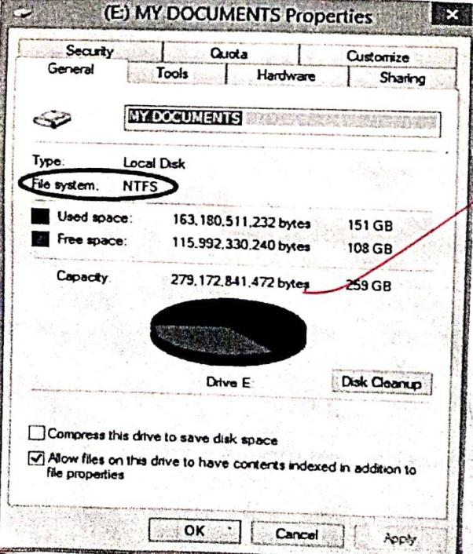

Disk formatting in the process of preparing data storage device such as a hard disk, Solid-state drive, floppy drive for initial use. In some cases, the formatting operation may also create one or more new more new file system

Formatting a disk allows the operating system to write a file system onto the disk so it can be used by the Operating System

Common file system include

**Windows Linux**

FAT 32 Ex+2

EXFAT (FAT 64) Ex+3

NTFS Ex+4

**OS Universal**

HS FCDFS

HSF+UDF

1. **Post installation tasks:**
2. Run windows update and configure update settings
3. Make sure os is activated
4. update your hardware driver
5. Install essential software
6. Setup a backup plan

**WEEK: 02**

**How to install ubuntu on Virtual Box.**

Virtual Box is a progress which allows you to install an operating system without computer's main operating system. To install ubuntu Linux on a computer by using Virtual Box follow

these steps:

Assuring that ubuntu is not in your system, let's first download ubuntu software.

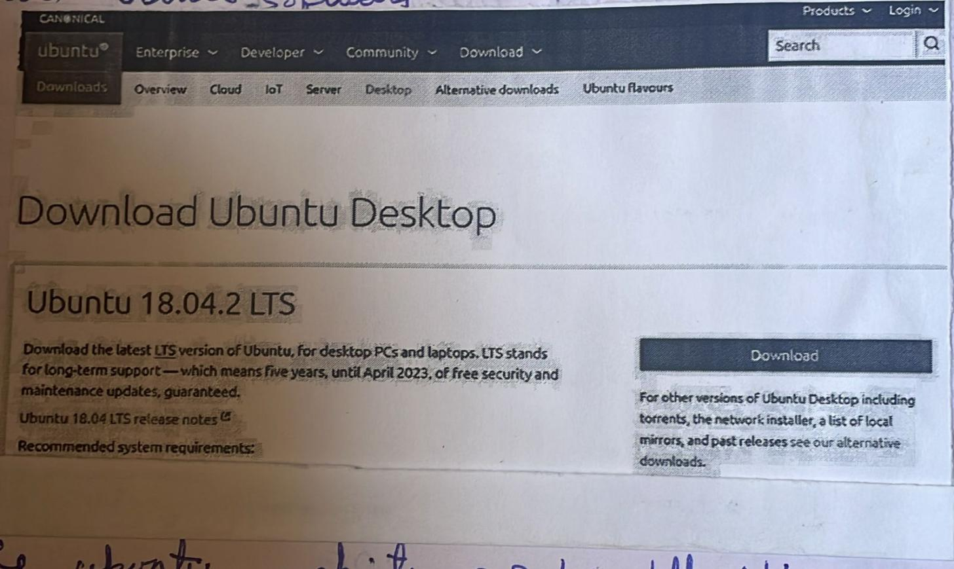

1.Open the ubuntu website, Go to https://www.ubuntu.com download / desktop in your computers web browser you can download the ubuntu disk image(also known as an ISO file) here.

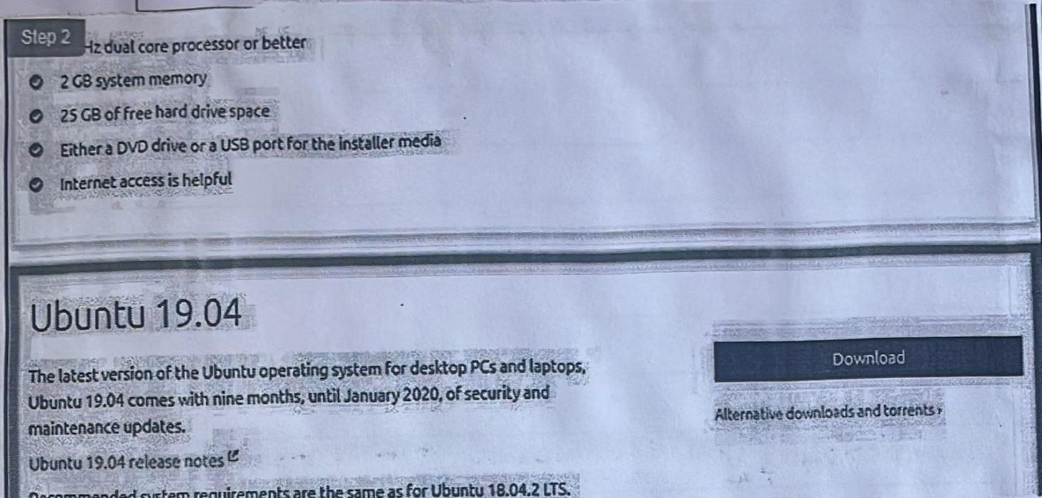

2. Scroll down to the latest version of ubuntu. you'll find it near the bottom of the page.

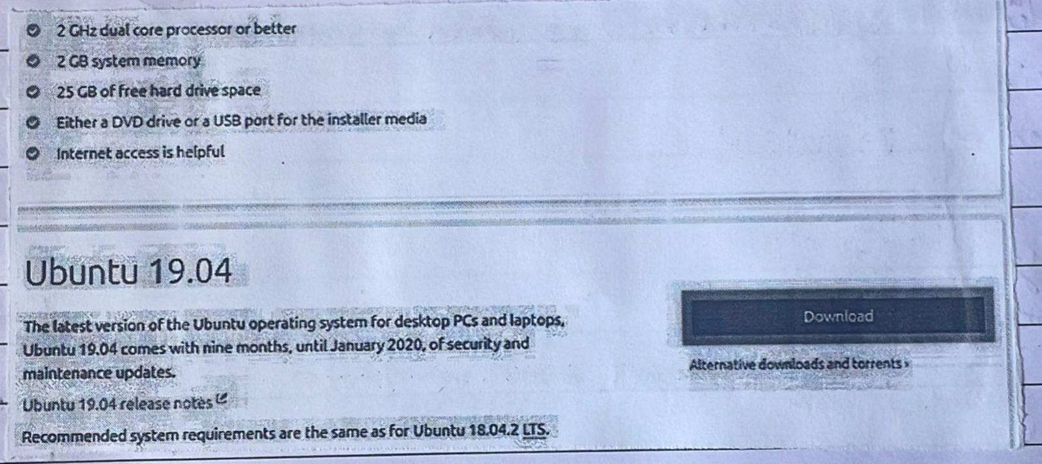

3. Chick Download. It's a green button to the right of your selected version of ubuntu. Doing

to the support page.

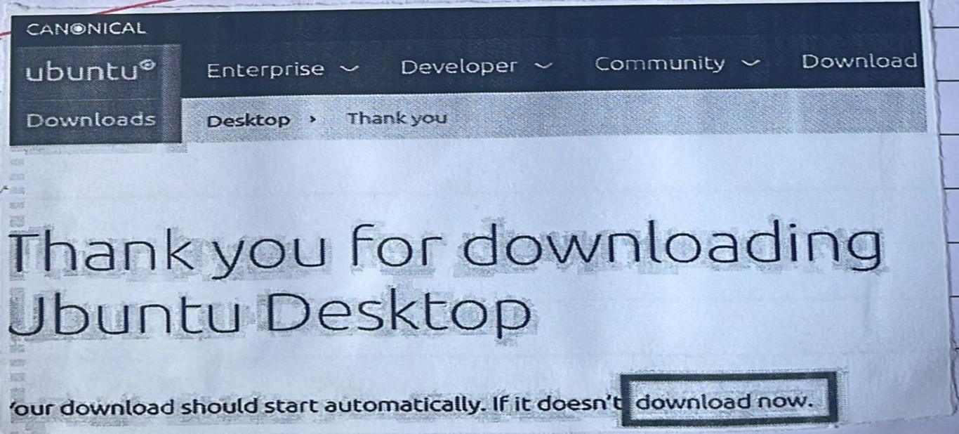

4. Scroll down and click "Download now". This link is in the bottom-left Corner of the Page

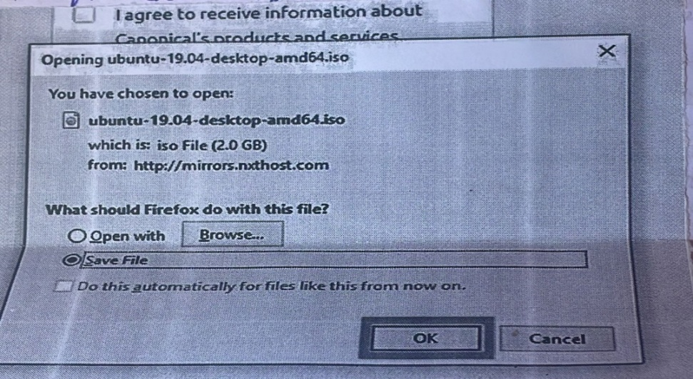

5. Make Sure that ubuntu begins downloading. The ubuntu ISO Should begin downloading immediately, but if it doen't, you can click the download now link at the top of the page. While the ubutu ISO downloads, you'll have plenty of time to set up your virtual machine in virtual box.

Creating a Virtual Machine

1. If you don't already have Virtual Box installed on your windows Computer you'll need to install if before

Install if before proceeding in your computers internet browser. This is the website from which you’ll download the virtual Box Setup File)

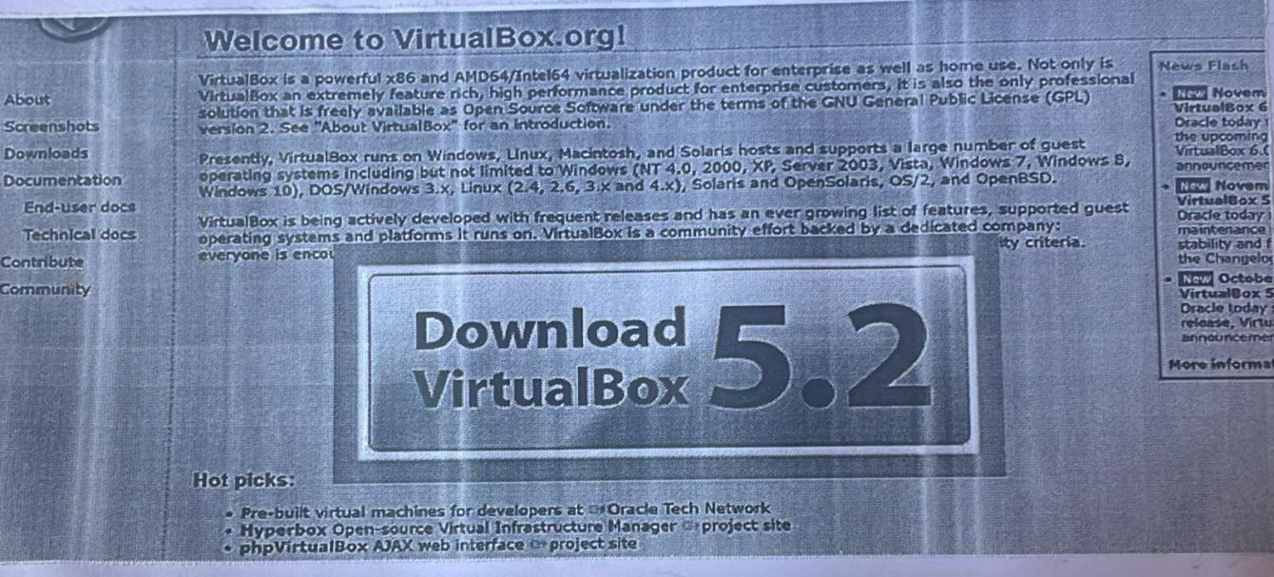

2. Click Download Virtual Box. It's a blue button in the middle of the page · Doing So will open the downloads.

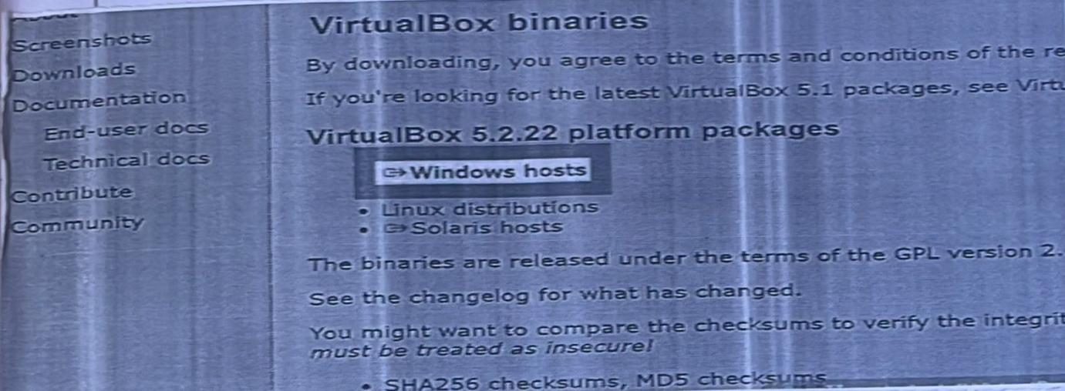

3. Click windows hosts you'll see this link below the virtual Box 6.1.14 platform packages “heading

The Virtual Box Exe file will begin downloading onto your computer

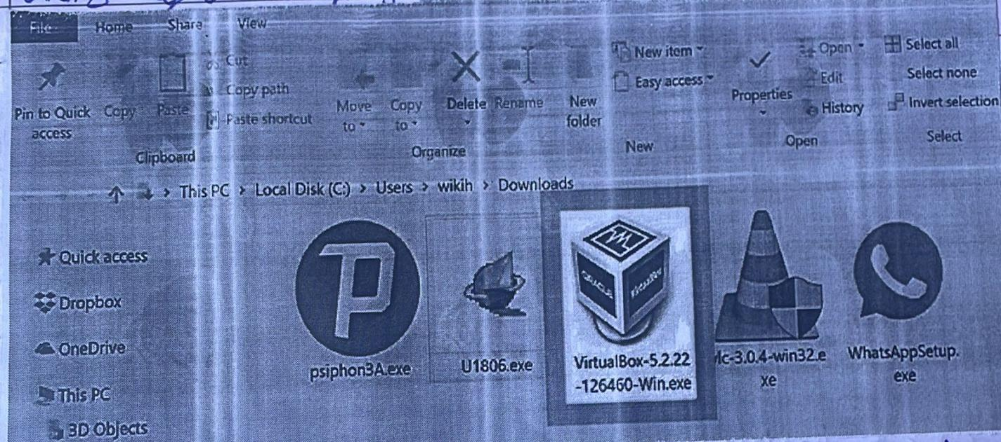

4. Open the virtual Box EXE file. Go to the location to which the EXE.file downloaded & double-click the file. Doing so will open the virtual Box Installation windows.

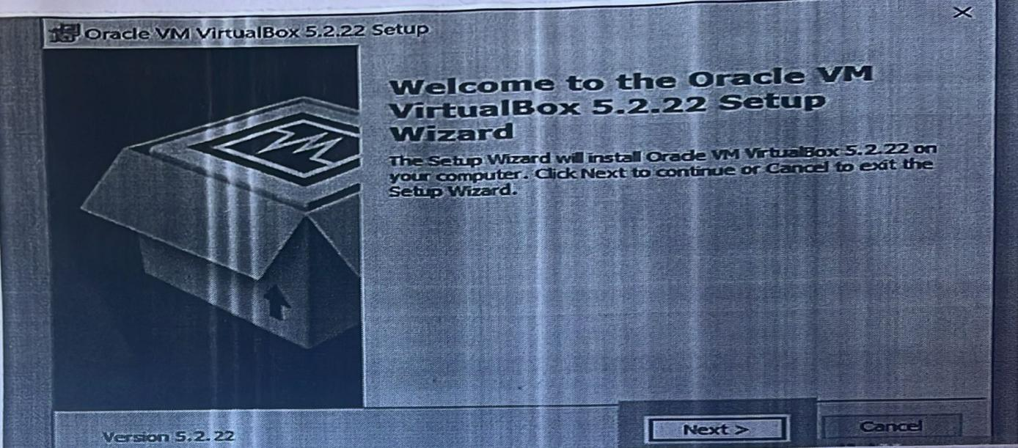

5. Navigate through the installation Prompts. Do the following.

Click Next on the first three Pages,Click Yes When Prompted and Click Install, Click Yes when Prompted

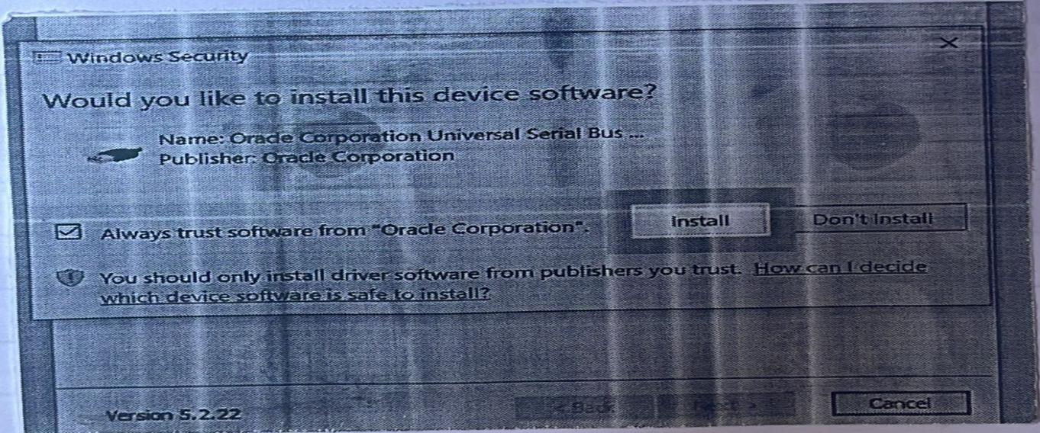

6. Click Install when prompted. Doing so will allow Virtual Box to begin installing on your computer.

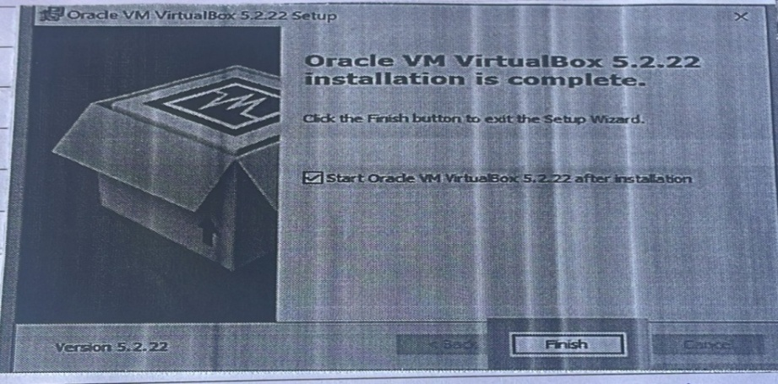

7. Click Finish when prompted. It's in the lower-right side of the window. Doing so will close the installation window and open Virtual Box. Now that you're installed and open Virtualbox, you can create a virtual machine in order to run any operating system on your PC.

•Make sure that you don't uncheck the "start” box before doing this

1. Open VirtualBox: Once you install VirtualBox, go to desktop and Open Virtual Box



9. Click New. It's blue badge in the upper-left Virtual Box window. Doing so open a pop-up menu File machine help

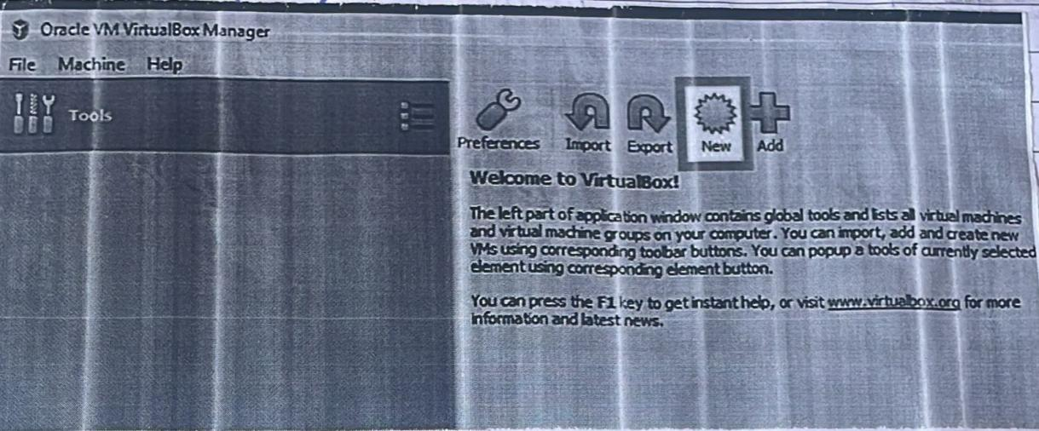

10. Enter a name for your virtual machine. Type whatever you want to name your virtual machine into the

“Name" textfield that's near the top of the pop-up menu.

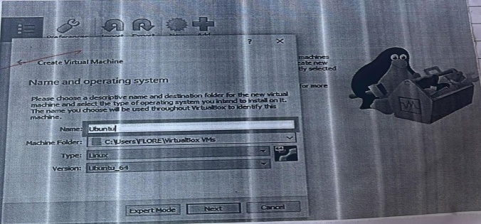

Once you type ubuntu, by default it will select Linux as its type or else select linux as the "Type" value. Click the "Type" drop-down box, then click Linux in the resulting drop-down menu.

11. Then Click Next. It’s at the bottom of the menu.

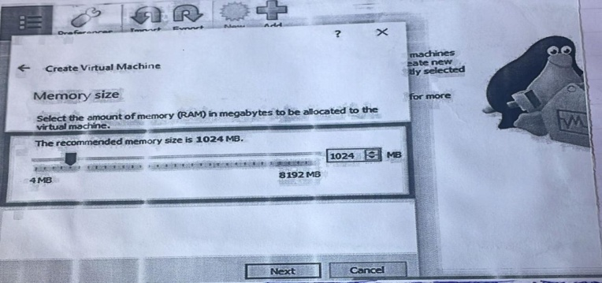

12. Create your virtual machine's virtual hard drive. The virtual hard drive a section of your computer's hard drive space which will be used to store your virtual machine's files and programs:

•Click Create → Click Next→ Click New

Select an amount of space to use. And Click Create.

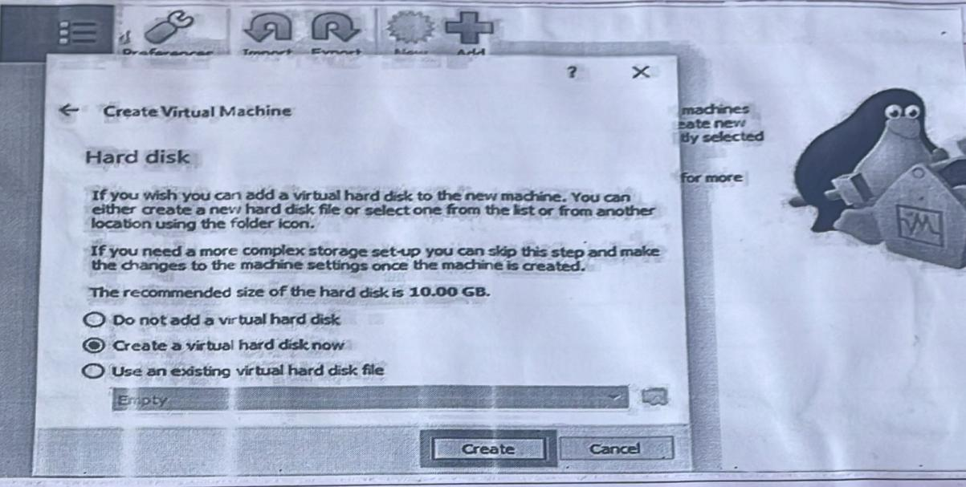

Make sure that your Ubuntu file is done downloading. Once the Ubuntu ISO finishes downloading, you can proceed with installing it to Virtual Box.

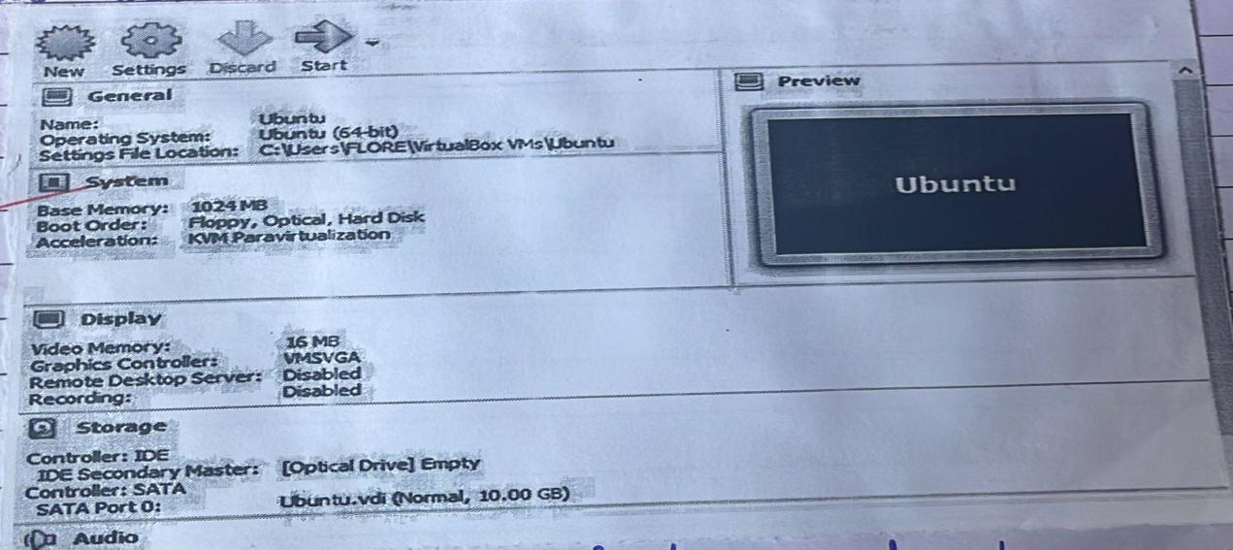

1. Double-click your virtual machine's name, It's on the left side of the Virtual Box window. Doing so will

Open a menu

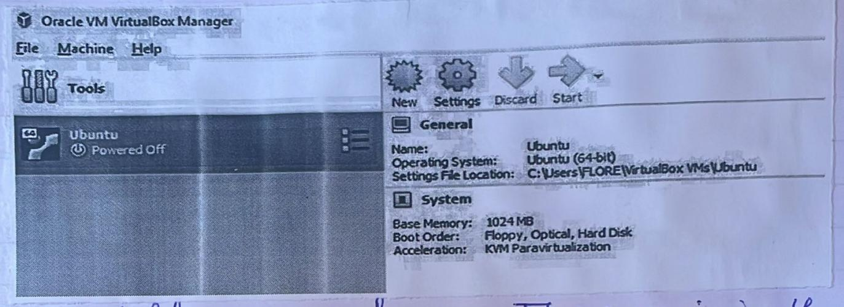

14.Click the folder-shaped icon. This icon is in the lower- right side of the menu. A new window in which you can select the ubuntu ISO will open.

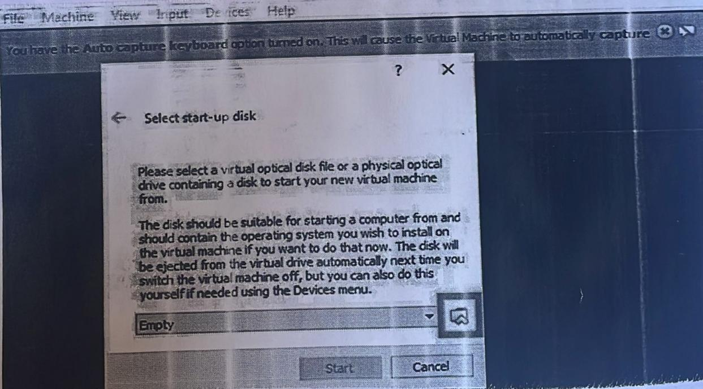

15.Selectyour Ubuntu ISO .Go to folder into which the Ubuntu ISO file download then click the ISO file to select it.

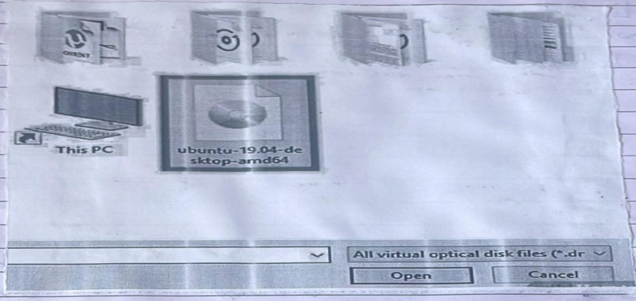

16.Click Open its in the bottom right corner of the window doing so open the ubuntu Iso file in virtual box.

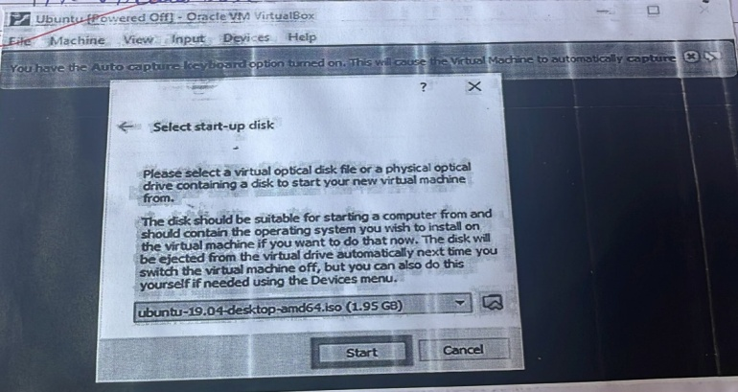

17.Click Start this option is the bottom of the menu ubuntu will begin running.

18.Click install ubuntu its on the right side of the virtual box window.

19.Click Continue. It's the bottom-right corner of the page.

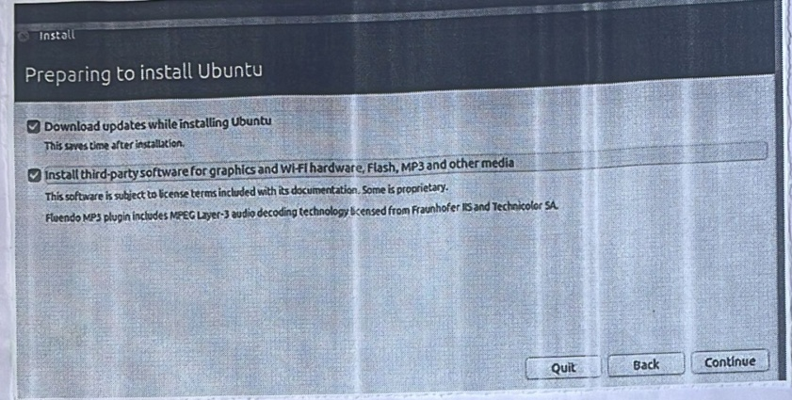

20.Check the "Erase disk and install Ubuntu" box. This may sound scary, but don't worry--nothing on your computer will be erased.

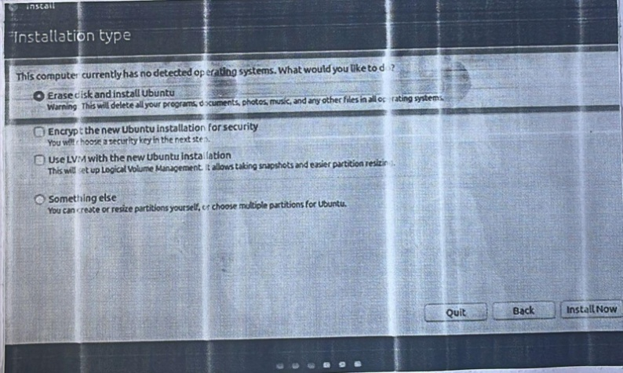

21. Click Continue when prompted. This confirms that you understand that the virtual machines virtual drive will be " erased" (there's nothing on it anyway) and begins the ubuntu installation process.

22. Click continue when prompted. This confirms that you understand that the virtual machines virtual drive will be "erased" (there is nothing on it anyway) and begins the ubuntu installation process.

Setting up Ubuntu

1.Select time zone .Click section that correlates with your position on the map .

2. Click Continue. It’s in the bottom -right corner of the page.

3. Enter your name. Do so in the “your name”text box at the top of the window.

*Entering a name will also create a computer name for your virtual machine, but you can create your own computer name as well by typing it into the “your computer’s name ”box.

4. Enter your name .Do so in the “Pick a username” text box type in the username that u want to use .

5. Create a password. Type your preferred password into the”Choose the password ”text box ,the re-type it in to the “Confirm your password ”text box.

6. Click Continue .it is at the bottom of the page.

*You can first select login options below the “Confirm your password” text field if need be.

7. Wait for ubuntu to finish installing. This process may take anywhere from a couple of minutes to half an hour depending on the speed of your computer.

*You won’t need to do anything during the installation process.



8.Restart the virtual machine .Once you see the Restart now button .do the following :

Click the exit button in the upper-right corner of window ,check the “power off the machine ”box, click OK ,and the double -click the virtual machine ‘s name.

9.Log into your computer .Once your Ubuntu virtual machine is back an select your name , the enter your password and sign in. Ubuntu will load your were using a separate computer .

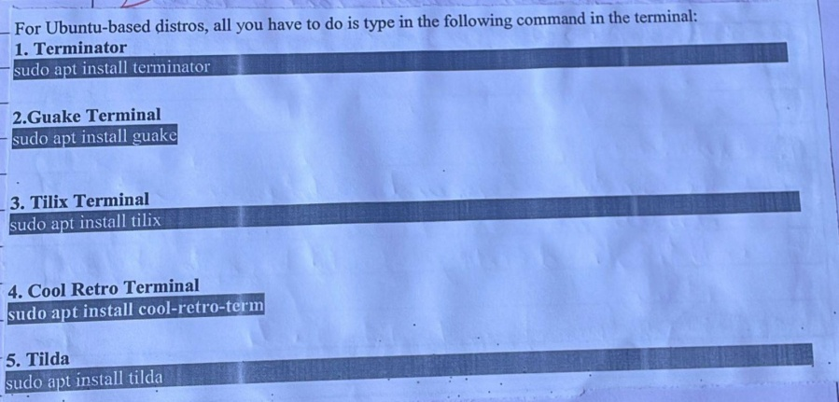

**Week 3**

**COMMANDS**

1. pwd:

* Will give the present working directory path information.
* Example: $pwd

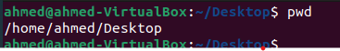

1. who:

* This command is used to view all the users accessed to the server.
* Ex: $who



1. mkdir:

* This command is used to create a directory.
* Syntax: mkdir (folder_name or path)
* Example: $mkdir khan



1. rmdir:

* The rmdir command deletes an empty directory.
* Note: The directory should be empty before deleting.
* Example: $rmdir tutorials

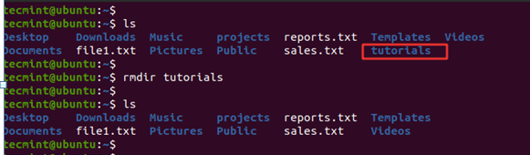

1. rm:

* The rm (remove) command is used to delete a file.
* Example: $rm ahmed

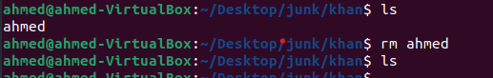

* Options:
* -R: Used to delete a directory.

Example: $rm -R project

[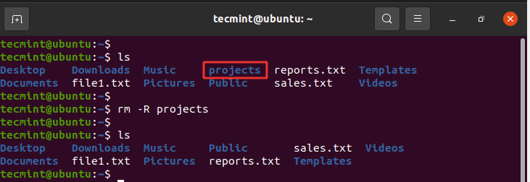](https://www.tecmint.com/wp-content/uploads/2021/03/Delete-Directory-Recursively-in-Linux.png)

1. touch:

* The touch command is used to create, change and modify timestamps of a file.
* Using this command we can create one or many files at a time.
* Example: touch a1
* Example 2: $touch a2 a3 a4

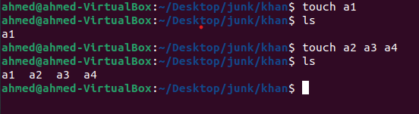

* Options:
* touch -a: This command is used to change access time only

Example: $touch -a a1

* touch -c: This command is used to check whether the file is created or not.

Example: $touch -c a1

* touch -c-d: This command is used to update access and modification time.

Example: $touch -c-d a1

* touch -m: This command is used to change the modification time only.

Example: $touch -m a1

* touch -r: This command is used to use the time stamp of another file.

Example: $touch -r second_file first_file

1. cd:

* This command is short for change directory, it is used to navigate to the prescribed path or within the directory.
* Use only cd to get back to the home.
* Example: $cd /var/log
* Example: $cd

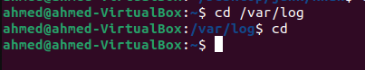

1. cat:

* This command is used to read the data from the file and given their content as output.
* It helps to create, view, append, write to a files.
* Functions:
* Create a new file:

$cat > f1

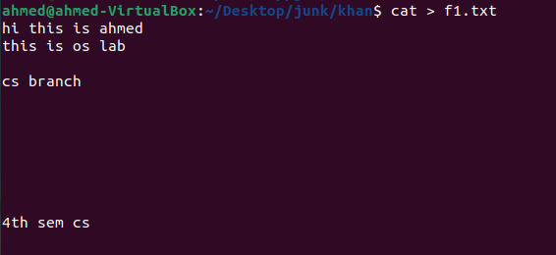

* To copy the contents of the file:

$cat [filename-whose-contents-is-to-be-copied] > [destination-filename]

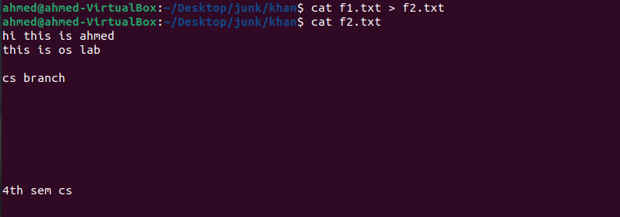

* To view the contents of a file:

$cat file1

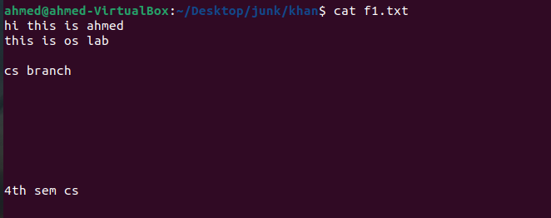

* To append the contents of one file to another:

$cat file1 >> file2

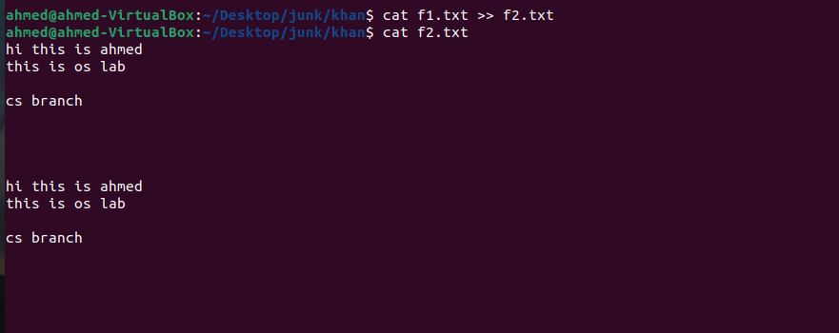

* To append the contents to a existing file:

$cat >> file2

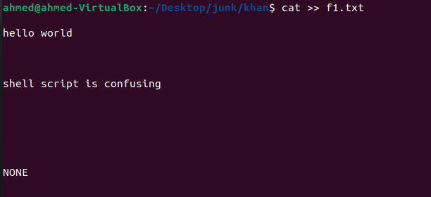

* To display the contents in reverse order:

$tac filename

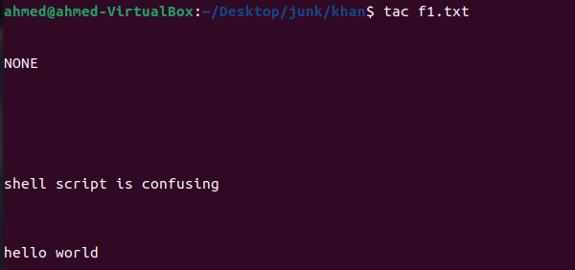

* Options:
* $cat -s: This will supress the repeated empty lines.

$cat -s f1

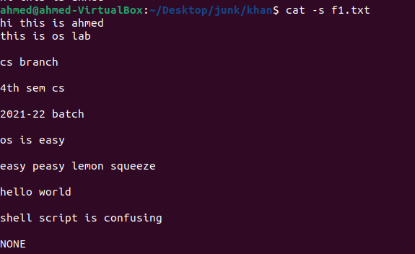

* $cat -n:

It will show the content with the line number.

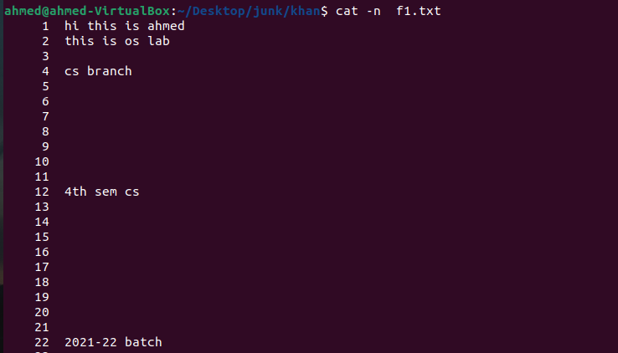

1. more:

* It is used to view the large files.
* It displays one screen at a time in case the file is large.
* Example: $more

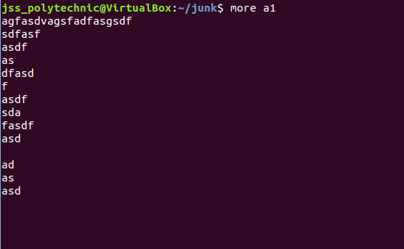

* Options:
* more -p : This options clears the screen and then displays the text.

Example: $more -p f1.txt

* more -s: this option squeezes the multiple blank lines one single blank line.

Example: $more -s f1.txt

1. less:

* This command is used to read the contents of a text file one page(one screen) at a time.
* It has faster access because if file is large it doesn’t access the complete file, but accesses it page by page.
* Example: $less f1.txt

1. ls:

* This command is used to display the files and directories that are stored in current directory
* Example: ls

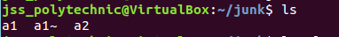

* Options:
* ls -l: This is used for long listing or the full detailed information of the files and folders of the current or prescribed folder.

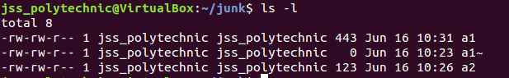

* ls -F: It is used to distinguish between files, folders and executable file by representing all with different symbols.
* ls -a: It is used to display all hidden files.
* ls -R: To show all the files recursively.
* ls -x: To show all files in columns.

1. mv (Move):

• Used to move the files from one location to another location.

• It can be used to rename the Files. Directory (Folder) also.

• Example 1:

o mv OldFileName NewFileName

o ls

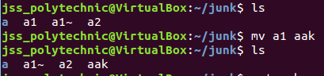

1. cp:

• Used to create a copy of a existing file.

• Make sure that the file to be copied must be exists in specified location.

• Syntax:

cp file1 file2

• Example:

* cp path1/file1 path2/file2

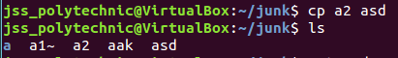

1. find:

* The [find command](https://www.tecmint.com/find-files-quickly-in-linux-terminal/) searches for a file in a particular location and takes two arguments: the search path or directory and the file to be searched.
* Syntax:

$find /path/to/search -name filename

* Example:

$find /home/tecmint -name f1.txt

[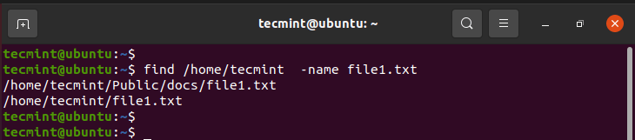](https://www.tecmint.com/wp-content/uploads/2021/03/Search-Files-in-Linux.png)

1. locate:

* The locate command, just like the find command, plays the same role of searching files but only takes one argument
* Syntax:

$locate filename

* Example:

$locate f1.txt

1. chmod:

* This command is used to change the permissions of the files.
* We can achieve it in 2 types:

1. Relative method
2. Absolute method
3. Relative method

* description: This command is used to change the file permissions. These permissions are read, write and execute permission for the owner, group, and others.
* syntax (symbolic mode):

**chmod [ugoa] [[+-=] [mode]] file**

* The first optional parameter indicates who – this can be (u)ser, (g)roup, (o)thers or (a)ll
* The second optional parameter indicates opcode – this can be for adding (+), removing (-) or assigning (=) permission.
* The third optional parameter indicates the mode – this can be (r)ead, (w)rite, or e(x)ecute.

Example:

**$ ls -l**

**-rw-r–r– 1 user staff 39 Jun 21 15:37 file1**

**-rw-r–r– 1 user staff 35 Jun 21 15:32 file2**

**$ chmod ugo+w file1**

**$ ls -l**

**-rw-rw-rw- 1 user staff 39 Jun 21 15:37 file1**

**-rw-r–r– 1 user staff 35 Jun 21 15:32 file2**

**$ chmod o-w file1**

**$ ls -l**

**-rw-rw-r– 1 user staff 39 Jun 21 15:37 file1**

**-rw-r–r– 1 user staff 35 Jun 21 15:32 file2**

1. **Absolute Permissions:**

* The mode is a combination of three digits – the first digit indicates the permission for the user, the second digit for the group, and the third digit for others.
* Each digit is computed by adding the associated permissions. Read permission is ‘4’, write permission is ‘2’ and execute permission is ‘1’.
* Syntax:

**chmod [mode] file**

* Example:

**$ ls -l**

**-rw-r–r– 1 user staff 39 Jun 21 15:37 file1**

**-rw-r–r– 1 user staff 35 Jun 21 15:32 file2**

**$ chmod 777 file1**

**$ ls -l**

**-rwxrwxrwx 1 user staff 39 Jun 21 15:37 file1**

**-rw-r–r– 1 user staff 35 Jun 21 15:32 file2**

1. crown:

* Description: Only the owner of the file has the rights to change the file ownership.
* Syntax: chown [owner] [file]
* Example: Change the owner of file1 to user2 assuming that it is currently owned by the current user

**$ chown user2 file1**

1. chgrp:
   * Description: Only the owner of the file has the rights to change the file ownership.
   * Syntax: chgrp [group] [file]
   * Example: Change group of file1 to group2 assuming it is currently owned by the current user.

**$ chgrp group2 file1**

1. umask:

* The mode is a combination of three digits – the first digit indicates the permission for the user, the second digit for the group, and the third digit for others.
* Each digit is computed by adding the associated permissions. Read permission is ‘4’, write permission is ‘2’ and execute permission is ‘1’.
* Syntax:

**$umask [mode]**

* Example:

**$umask 777**

1. tar:

* This command is used for making archive (archive means to store many files as one file, when we want we can separate those files).
* In other words, we can use this command to compress and expand the files.
* Options:
* tar – c: Creating archive
* tar – v: Displaying
* tar – f: To give archive name
* tar – x: Extract
* tar – z: after archiving to make it zip.
* Example:
* To create the archive:

$tar -cvf ach.tar f1.txt f2.txt f3.txt f4.txt

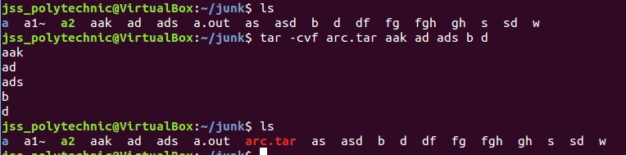

* To extract the files from archive:

$tar -xvf ach.tar

1. gzip:

* This command is used to zip a file.
* After the file is zipped, it will have ‘.gz’ extention.
* Syntax:

gzip [Option] [archive name/file name]

* Example:

**$gzip aak**

**Output:**

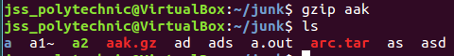

1. gunzip:

* This command is used to un-zip a file.
* After the file is un-zipped, it will remove ‘.gz’ extention
* Syntax:

gunzip [Option] [archive name/file name]

* Example:

**$gunzip aak.gz**

**Output:**

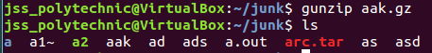

1. cmp:

* This command is used to show the content of the file which is not same
* Syntax:

cmp file1 file2

* Example:

cmp f1.txt f2.txt

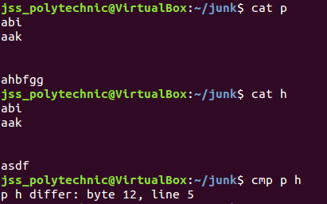

1. comm:

* This command is used to show the common content of the both the file.
* **NOTE: Before Using this command, both the file contents should be sorted.**
* Syntax:

comm file1 file2

* Example:

comm f1.txt f2.txt

1. diff:

* This command gives the suggestion to change the content of the files to make both the file same.
* Syntax:

diff file1 file2

* Example:

diff f1.txt f2.txt

1. wc:

* This command is used to count the words.
* Using the commands without the arguments gives us the number of lines, words, characters.
* Example:

$wc f1.txt

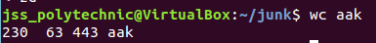

* Options:
* wc -l: To display only number of lines.
* wc -c: To display only number of characters.
* wc -w: To display only number of words.

1. head:

* To show the 10 lines from the top of the file (10 number of lines is default).
* Example:

head f1.txt

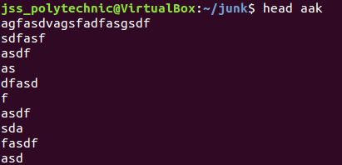

* Options:
* head -k: Used to display only prescribed number of lines from the top of the file.

Example:

head -6 f1.txt

1. tail:

* To show the 10 lines from the bottom of the file (10 number of lines is default).
* Example:

tail f1.txt

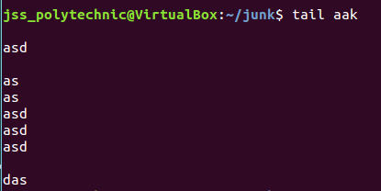

* Options:
* tail -k: Used to display only prescribed number of lines from the bottom of the file.

Example:

tail -6 f1.txt

1. cut:

* This command is used for sliting a file vertically.
* **Example:**

cut –c 9-16, 19-26 emp

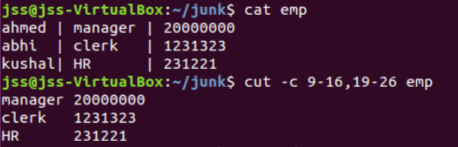

* Example 2: cut –d “|” –f 1,3 emp

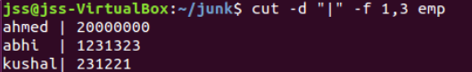

* **Options:**
  + cut –f : This option is used for extracting the fields from files.
* cut –d: this is used to specify the delimiter.
* cut –c: this option in used for cutting the fields.

1. paste:

* This command is used to paste the file vertically.
* **Example:** $paste f1 f2

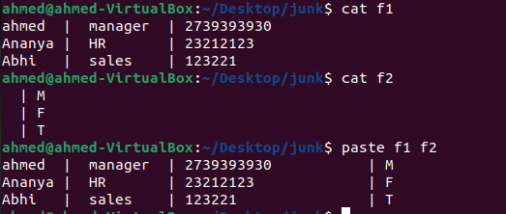

* **Options:**
* Paste -d: This option is used to give the prescribed delimiter between the files to be pasted.
* Paste -s: This option is used to join all the lines to form single line.

1. uniq:

* This command is used to locate the repeated and non repeated characters in the consecutive lines only once.
* **Example:** $uniq f1

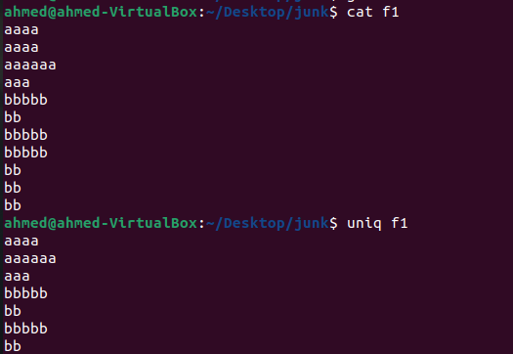

* **Options:**
* -u: selects the non-repeated lines.
* -d: shows only one line of what is repeated.
* -c: shows how many times it is repeated.

1. tr:

* This filter is used for manipulating individual characters in a line
* **Example:**
* tr ‘[a-z]’ ‘[A-Z]’ < emp

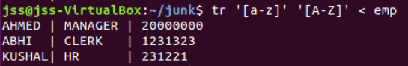

* tr ‘\’ ‘|’ < emp

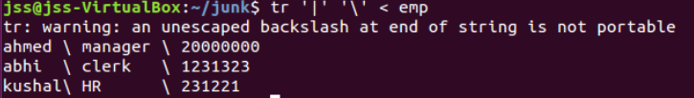

* **Options:**
* -d: this option is used to deleting the character.
* -s: this option is used to compress multiple consecutive character.
* -c: Complements the set of characters in the expression.

1. pr:

* This command is used to make a file printing appropriate.
* **Example:** pr f1
* **Options:**
* **-k:** This option is used to distribute the content in prescribed number of lines.
* **-n:** Gives numbers for each lines.
* **-d:** Gives one line space after every line
* **-o:** This is used to give prescribed number of gaps at the starting of every line in the file. This is used to give the left margin.
* **-t:** used to remove extra spaces if present in the file.
* **-h:** Used to prescribe the header to a file.

1. sort:

* This command is used to sort the file.
* This command sorts the content in the ASCII collating sequence – space, numerals, uppercase and lowercase.
* **Example:** $sort f1

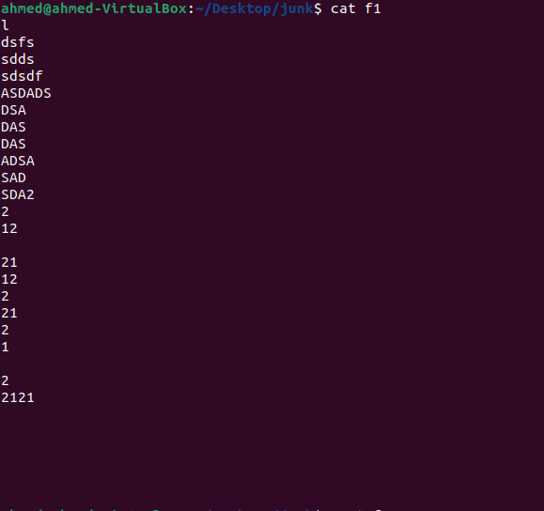

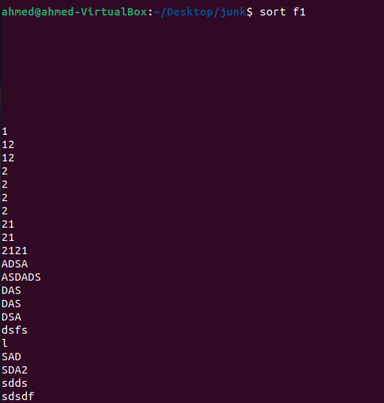

* **Options:**
* -k: to sort the fields or columns.
* -t: to specify delimiter.
* -n: to sort the files containing only numbers.
* -u: unique option allows you to remove repeated lines.
* -r: to sort in reverse order.

**Week-3 File management Commands**

**Text Processing Commands and Filters**

The grep filter searches a file for a particular pattern of characters, and displays all lines that contain that pattern. The pattern that is searched in the file is referred to as the regular expression (grep stands for global search for regular expression and print out).  
**Syntax:**   
 **grep [options] pattern [files]**

**Options Description**

**-c** : This prints only a count of the lines that match a pattern

**-h :** Display the matched lines, but do not display the filenames.

**-i :** Ignores, case for matching

**-l :** Displays list of a filenames only.

**-n :** Display the matched lines and their line numbers.

**-v :** This prints out all the lines that do not matches the pattern

**-e exp :** Specifies expression with this option. Can use multiple times.

**-f file :** Takes patterns from file, one per line.

**Sample Commands**

Consider the below file as an input. 

**$cat > geekfile.txt**

 unix is great os. unix is opensource. unix is free os.

learn operating system.

Unixlinux which one you choose.

uNix is easy to learn.unix is a multiuser os.Learnunix .unix is a powerful.

**1. Case insensitive search :**The -i option enables to search for a string case insensitively in the given file. It matches the words like “UNIX”, “Unix”, “unix”. 

**$grep -i "UNix" geekfile.txt**

**Output:**   
 unix is great os. unix is opensource. unix is free os.

Unixlinux which one you choose.

uNix is easy to learn.unix is a multiuser os.Learnunix .unix is a powerful.

**2. Displaying the count of number of matches :** We can find the number of lines that matches the given string/pattern 

**$grep -c "unix" geekfile.txt**

**Output:** 

2

**Advanced Filters**

**SED command** in UNIX stands for stream editor and it can perform lots of functions on file like searching, find and replace, insertion or deletion. Though most common use of SED command in UNIX is for substitution or for find and replace.

**sed OPTIONS... [SCRIPT] [INPUTFILE...]**

**Example:**  
Consider the below text file as an input.

**$cat > geekfile.txt**

unix is great os. unix is opensource. unix is free os.

learn operating system.

unixlinux which one you choose.

unix is easy to learn.unix is a multiuser os.Learnunix .unix is a powerful.

**Sample Commands**

**Replacing or substituting string :** Sed command is mostly used to replace the text in a file. The below simple sed command replaces the word “unix” with “linux” in the file.

**$sed 's/unix/linux/' geekfile.txt**

**Output :**

linux is great os. unix is opensource. unix is free os.

learn operating system.

linuxlinux which one you choose.

linux is easy to learn.unix is a multiuser os.Learnunix .unix is a powerful.

Here the “s” specifies the substitution operation. The “/” are delimiters. The “unix” is the search pattern and the “linux” is the replacement string.

By default, the sed command replaces the first occurrence of the pattern in each line and it won’t replace the second, third…occurrence in the line.

**Replacing the nth occurrence of a pattern in a line :** Use the /1, /2 etc flags to replace the first, second occurrence of a pattern in a line. The below command replaces the second occurrence of the word “unix” with “linux” in a line.

**$sed 's/unix/linux/2' geekfile.txt**

**Output:**

unix is great os. linux is opensource. unix is free os.

learn operating system.

unixlinux which one you choose.

unix is easy to learn.linux is a multiuser os.Learnunix .unix is a powerful.

**Replacing all the occurrence of the pattern in a line :**The substitute flag /g (global replacement) specifies the sed command to replace all the occurrences of the string in the line.

**$sed 's/unix/linux/g' geekfile.txt**

**Output :**

linux is great os. linux is opensource. linux is free os.

learn operating system.

linuxlinux which one you choose.

linux is easy to learn.linux is a multiuser os.Learnlinux .linux is a powerful.

**Replacing from nth occurrence to all occurrences in a line :**Use the combination of /1, /2 etc and /g to replace all the patterns from the nth occurrence of a pattern in a line. The following sed command replaces the third, fourth, fifth… “unix” word with “linux” word in a line.

**$sed 's/unix/linux/3g' geekfile.txt**

**Output:**

unix is great os. unix is opensource. linux is free os.

learn operating system.

unixlinux which one you choose.

unix is easy to learn.unix is a multiuser os.Learnlinux .linux is a powerful.

**Replacing string on a specific line number :**You can restrict the sed command to replace the string on a specific line number. An example is

**$sed '3 s/unix/linux/' geekfile.txt**

**Output:**

unix is great os. unix is opensource. unix is free os.

learn operating system.

linuxlinux which one you choose.

unix is easy to learn.unix is a multiuser os.Learnunix .unix is a powerful.

The above sed command replaces the string only on the third line.

**Duplicating the replaced line with /p flag :**The /p print flag prints the replaced line twice on the terminal. If a line does not have the search pattern and is not replaced, then the /p prints that line only once.

**$sed 's/unix/linux/p' geekfile.txt**

**Output:**

linux is great os. unix is opensource. unix is free os.

linux is great os. unix is opensource. unix is free os.

learn operating system.

linuxlinux which one you choose.

linuxlinux which one you choose.

linux is easy to learn.unix is a multiuser os.Learnunix .unix is a powerful.

linux is easy to learn.unix is a multiuser os.Learnunix .unix is a powerful.

**Printing only the replaced lines :**Use the -n option along with the /p print flag to display only the replaced lines. Here the -n option suppresses the duplicate rows generated by the /p flag and prints the replaced lines only one time.

**$sed -n 's/unix/linux/p' geekfile.txt**

**Output:**

linux is great os. unix is opensource. unix is free os.

linuxlinux which one you choose.

linux is easy to learn.unix is a multiuser os.Learnunix .unix is a powerful.

If you use -n alone without /p, then the sed does not print anything.

**Replacing string on a range of lines :** You can specify a range of line numbers to the sed command for replacing a string.

**$sed '1,3 s/unix/linux/' geekfile.txt**

**Output:**

linux is great os. unix is opensource. unix is free os.

learn operating system.

linuxlinux which one you choose.

unix is easy to learn.unix is a multiuser os.Learnunix .unix is a powerful.

Here the sed command replaces the lines with range from 1 to 3. Another example is

**$sed '2,$ s/unix/linux/' geekfile.txt**

**Output:**

unix is great os. unix is opensource. unix is free os.

learn operating system.

linuxlinux which one you choose.

linux is easy to learn.unix is a multiuser os.Learnunix .unix is a powerful

Here $ indicates the last line in the file. So the sed command replaces the text from second line to last line in the file.

**Deleting lines from a particular file :** SED command can also be used for deleting lines from a particular file. SED command is used for performing deletion operation without even opening the file  
Examples:  
1. To Delete a particular line say n in this example

Syntax:

$ sed 'nd' filename.txt

Example:

$ sed '5d' filename.txt

2. To Deletea last line

Syntax:

$ sed '$d' filename.txt

**Awk** is a scripting language used for manipulating data and generating reports. The awk command programming language requires no compiling and allows the user to use variables, numeric functions, string functions, and logical operators.

Awk is a utility that enables a programmer to write tiny but effective programs in the form of statements that define text patterns that are to be searched for in each line of a document and the action that is to be taken when a match is found within a line. Awk is mostly used for pattern scanning and processing. It searches one or more files to see if they contain lines that matches with the specified patterns and then perform the associated actions.

Awk is abbreviated from the names of the developers – Aho, Weinberger, and Kernighan.

**Example:**

Consider the following text file as the input file for all cases below:

$cat > employee.txt

ajay manager account 45000

sunil clerk account 25000

varun manager sales 50000

amit manager account 47000

tarun peon sales 15000

Deepak clerk sales 23000

sunil peon sales 13000

satvik director purchase 80000

**1. Default behavior of Awk:**By default Awk prints every line of data from the specified file.

$ awk '{print}' employee.txt

**Output:**

ajay manager account 45000

sunil clerk account 25000

varun manager sales 50000

amit manager account 47000

tarun peon sales 15000

deepak clerk sales 23000

sunil peon sales 13000

satvik director purchase 80000

In the above example, no pattern is given. So the actions are applicable to all the lines. Action print without any argument prints the whole line by default, so it prints all the lines of the file without failure.

**2. Print the lines which match the given pattern.**

$ awk '/manager/ {print}' employee.txt

**Output:**

ajay manager account 45000

varun manager sales 50000

amit manager account 47000

In the above example, the awk command prints all the line which matches with the ‘manager’.

**3. Splitting a Line Into Fields :**For each record i.e line, the awk command splits the record delimited by whitespace character by default and stores it in the $n variables. If the line has 4 words, it will be stored in $1, $2, $3 and $4 respectively. Also, $0 represents the whole line.

$ awk '{print $1,$4}' employee.txt

**Output:**

ajay 45000

sunil 25000

varun 50000

amit 47000

tarun 15000

deepak 23000

sunil 13000

satvik 80000

**Week 4**

1. **bg:**

* **bg** is used to place foreground jobs in background.
* used to send a process running in the foreground to the background in the current shell.
* **Example:**
* **$bg**
* **$wc -l f1&**
* **$bg**

1. **ps:**

* This command is used to display the processes associated with a user at the terminal.
* **Options:**

1. **–f**- full listing to grt detailed listing which also shows the parent of every process
2. **–u**-to know the activities of any user
3. **–a**- all option displays or lists the processes of all users but do not displays the system processes.
4. **–e or –A**- displays all processes including system processes and user processes

System processes are identified by ? in TTY. They will not be having any controlling terminal

**$ps ux**

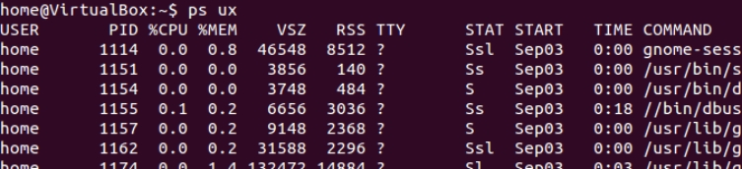

**$ps PID**



1. **fg:**

You can use the command “fg” to continue a program which was stopped and bring it to the foreground.

The simple syntax for this utility is:

fg jobname

**$fg %1 brings first job to foreground**

**$fg %sort brings sort job to foreground**

**$bg %2 sends second job to background**

1. **top:**
   * This command is used to vies all the running processes on the machine
   * **Example:**

* **$top**

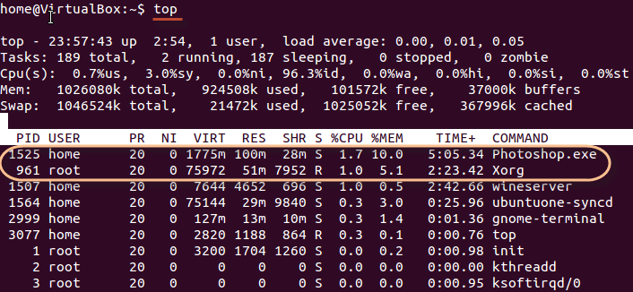

1. **kill:**

* This command is used to kill or terminate the running processed on the machine
* **Syntax:** $kill PID
* **Example:** $kill 1

1. **nice:**

* Linux can run a lot of processes at a time, which can slow down the speed of some high priority processes and result in poor performance.
* To avoid this, you can tell your machine to prioritize processes as per your requirements.This priority is called Niceness in Linux, and it has a value between -20 to 19. The lower the Niceness index, the higher would be a priority given to that task.
* The default value of all the processes is 0.
* **Example:** $nice -n 19 a10.sh

1. **df:**

* This command is used to display the information related to file systems about total space and available space.
* **Example:** df /home/ubuntu/ali.txt



* **Options:**
* **df -h:** This option is used for displaying the size in power of 1024.

**Example:** df -h /home/ubuntu/ali.txt

* **df -H:** This option is used for displaying the size in the power of 1000.

**Example:** df -H /home/ubuntu/ali.txt

* **df -T:** This option is used for displaying the type of the file.

**Example:** df -T /home/ubuntu/ali.tx

1. **free:**

* This command is used to view the memory consumption.
* **Example:** free



* **Options:**
* **free -m:** this option is used to view in MBs.
* **free -k:** this option is used to view in KBs.
* **free -g:** this option is used to view in GBs.

1. **cron:**
2. The **crontab** is list of commands to execute the scheduled tasks at specific time. It allows the user to add, remove or modify the scheduled tasks.

**File Name**: task.sh

**path: /home/admincs/**(say for example)

**Contents:**

echo Welcome to Task Scheduler Demo

echo Try date Command

date

echo Try time Command

time

echo List all file/folders in a home directory

ls

echo End of Task Scheduler Demo

1. Change the execution permission to task.sh

**chmod 764 task.sh**

Add the task to /etc/crontab

(Task will be executed at 4.13pm, User can Change

timings according to the requirements)

**13 16 * * * root sh /home/admincs/task.sh > /home/admincs/output.txt**

1. Save and Exit. And Wait till 4.13pm
2. After that Check the output.txt by the command
3. **at:**
4. at command is a command-line utility that is used to schedule a command to be executed at a particular time in the future.
5. Jobs created with at command are executed only once.
6. **Working with at command**

•Command to list the user’s pending jobs:

o **at -l**

**OR**

o **atq**

•Schedule a job for the coming Monday at a time twenty minutes later than the current time:

o **at Monday +20 minutes**

•Schedule a job to run at 1:45 Aug 12 2020:

o **at 1:45 081220**

•Schedule a job to run at 3pm four days from now:

o **at 3pm + 4 days**

•Schedule a job to shutdown the system at 4:30 today:

o **echo "shutdown -h now" | at -m 4:30**

•Schedule a job to run five hour from now:

o **at now +5 hours**

**Week 5**

1. **ps:**

* This command is used to display the processes associated with a user at the terminal.
* **Options:**

1. **–f**- full listing to grt detailed listing which also shows the parent of every process
2. **–u**-to know the activities of any user
3. **–a**- all option displays or lists the processes of all users but do not displays the system processes.
4. **–e or –A**- displays all processes including system processes and user processes

System processes are identified by ? in TTY. They will not be having any controlling terminal

**$ps ux**



**$ps PID**



1. **top:**
   * This command is used to vies all the running processes on the machine
   * **Example:**

* **$top**



1. **htop:**

* This command is an ncurses-based interactive processor viewer which is used to monitor individual threads in tree views.
* **Example:** htop

**Week 6**

1. **free:**

* This command is used to view the memory consumption.
* **Example:** free



* **Options:**
* **free -m:** this option is used to view in MBs.
* **free -k:** this option is used to view in KBs.
* **free -g:** this option is used to view in GBs.

1. **cat /proc/meminfo:**

* This is used to determine how much memory the computer has.
* **Example:** cat /proc/meminfo

1. **vmstat:**

* This command is a useful tool that reports Virtual memory statistics.
* vmstat provides general information about, processes, memory, paging, block, IO, traps and CPU activities.
* **Example:** $vmstat

1. **top:**
   * This command is used to vies all the running processes on the machine
   * **Example:**

* **$top**



1. **htop:**

* This command is an ncurses-based interactive processor viewer which is used to monitor individual threads in tree views.
* **Example:** htop

**Week 7**

**Shell script:**

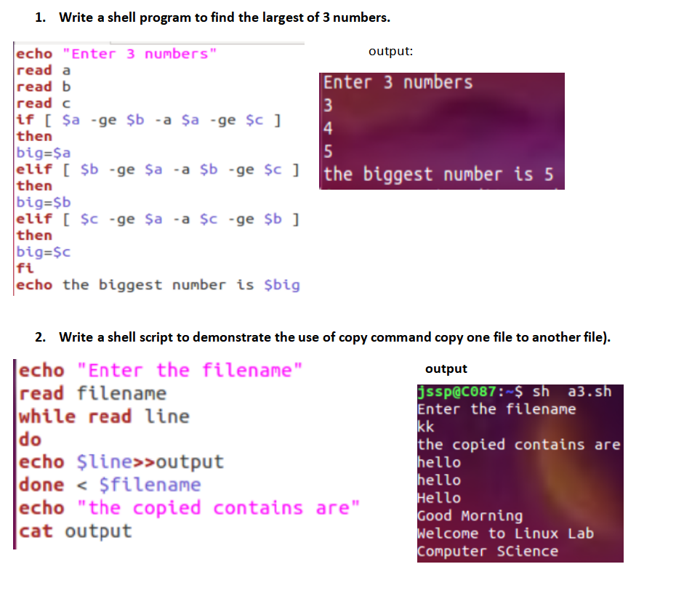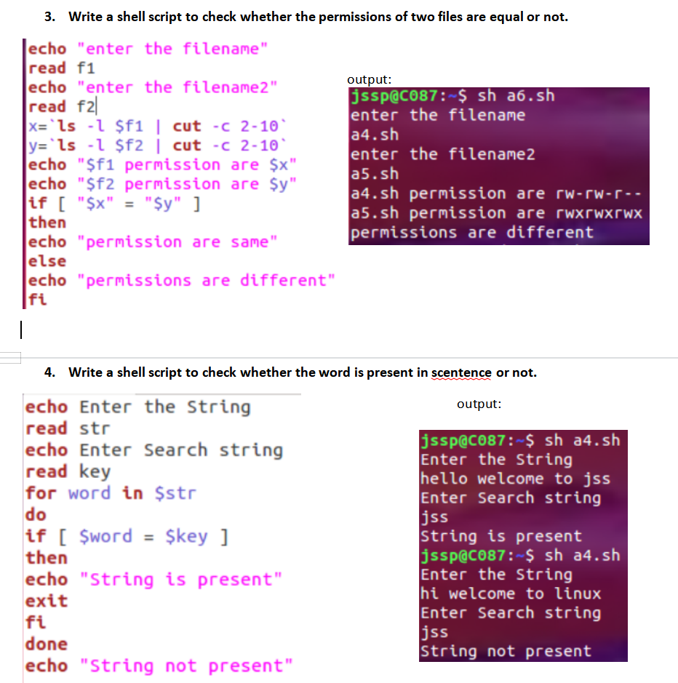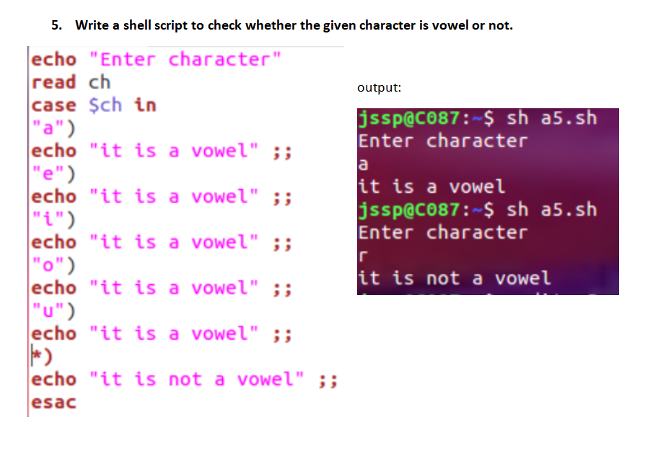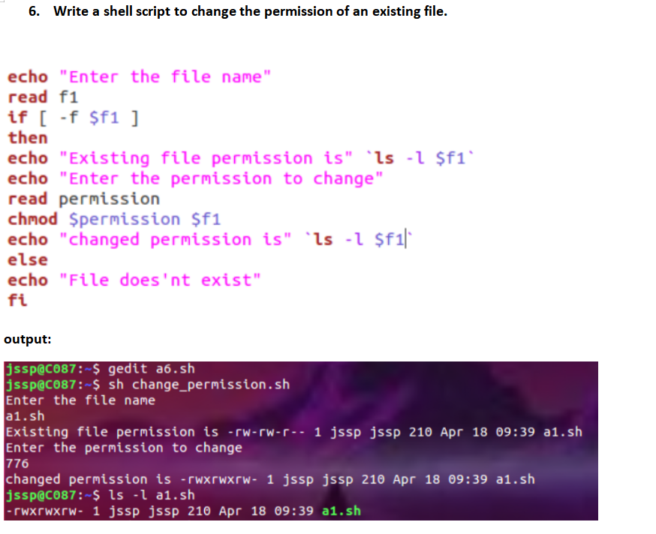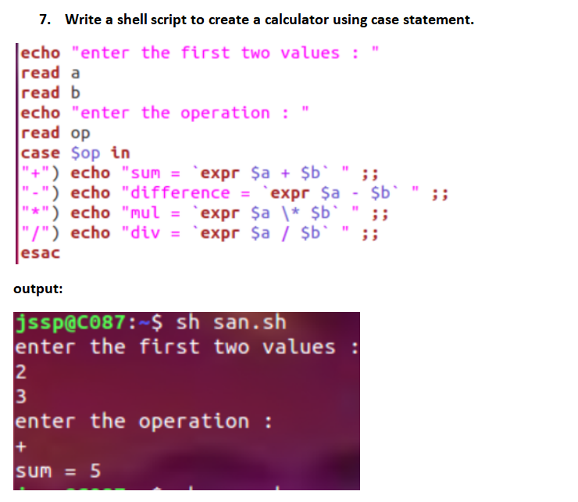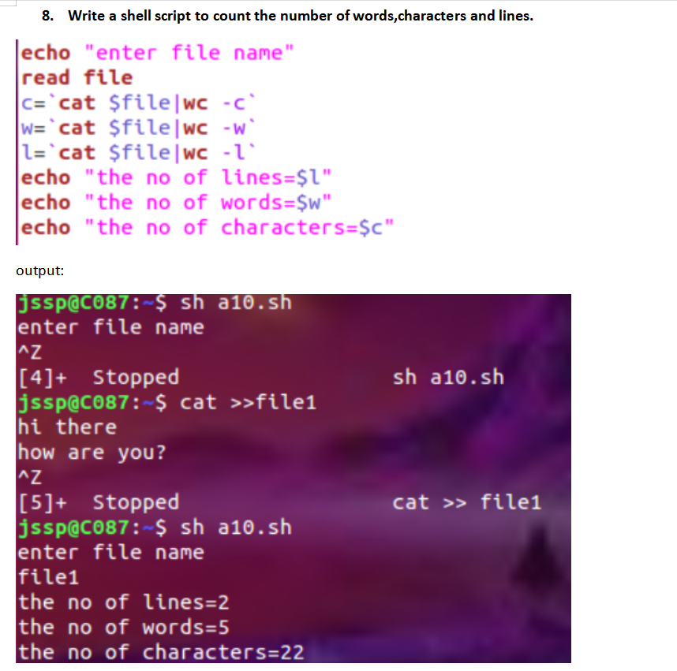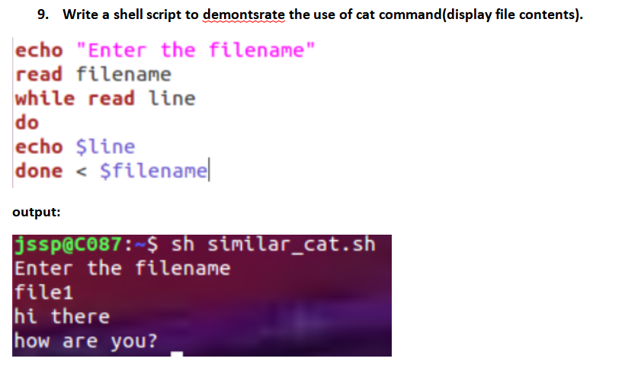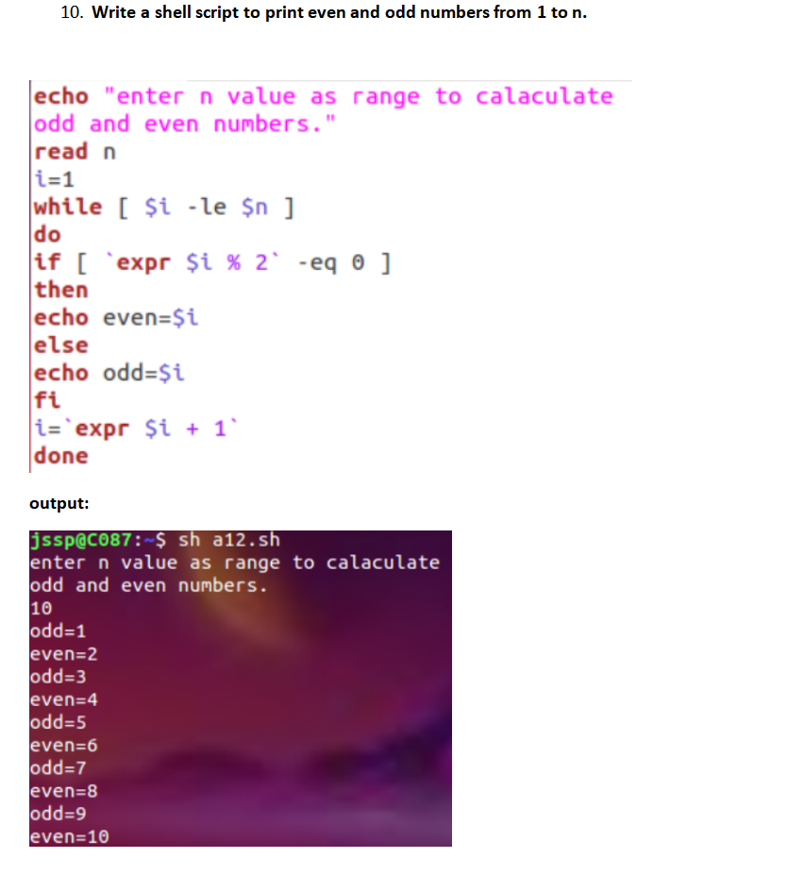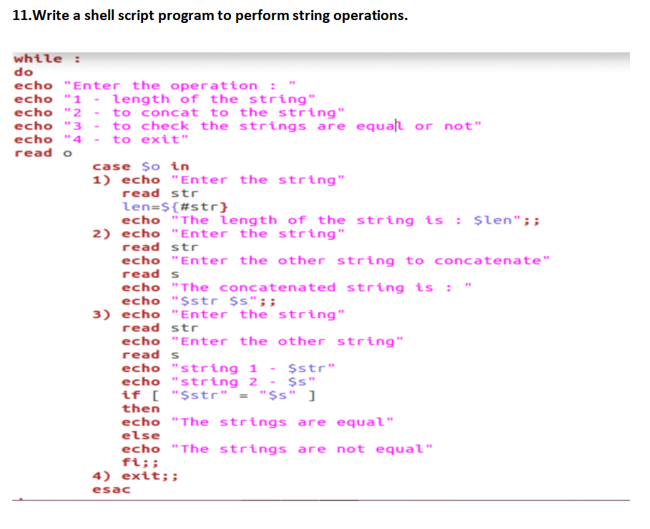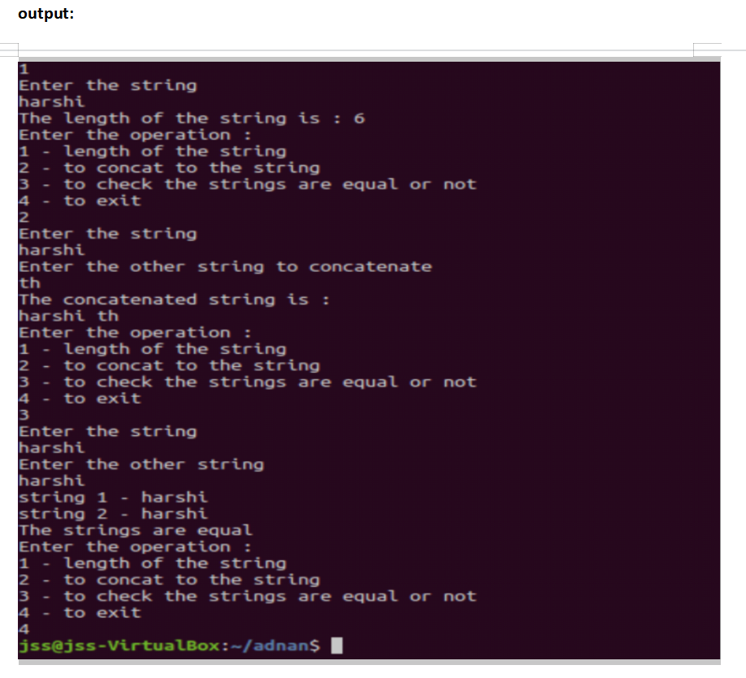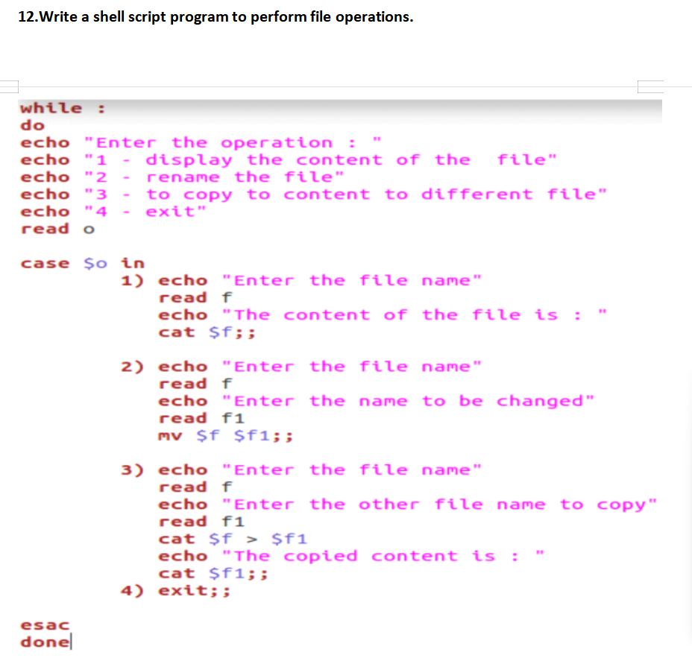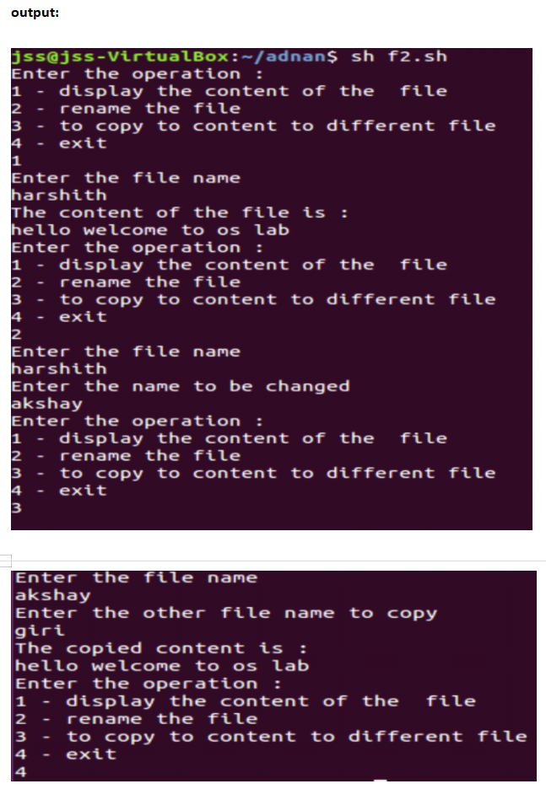

**Week 8**

**Automation tasks:**

1. **Crontab:**

* The **crontab** is list of commands to execute the scheduled tasks at specific time. It allows the user to add, remove or modify the scheduled tasks.

**File Name**: task.sh

**path: /home/admincs/**(say for example)

**Contents:**

echo Welcome to Task Scheduler Demo

echo Try date Command

date

echo Try time Command

time

echo List all file/folders in a home directory

ls

echo End of Task Scheduler Demo

* Change the execution permission to task.sh

**chmod 764 task.sh**

Add the task to /etc/crontab

(Task will be executed at 4.13pm, User can Change

timings according to the requirements)

**13 16 * * * root sh /home/admincs/task.sh > /home/admincs/output.txt**

* Save and Exit. And Wait till 4.13pm
* After that Check the output.txt by the command
* **Example 2: Other Simple Example to Schedule user or System Tasks:**

**• Note:**To schedule user task, the shell script path must be specified in place of **/path/to/script**

* Specify the interval at which user want to schedule the tasks using the cron job entries we specified earlier on.
* To reboot a system daily at 12:30 pm, use the syntax:

o **30 12 * * * /sbin/reboot**

* To schedule the reboot at 4:00 am use the syntax:

o **4 * * * /sbin/reboot**

* **Note:** The asterisk * is used to match all records
* To run a script twice every day, for example, 4:00 am and 4:00 pm, use the syntax.

o **4,16 * * * /path/to/script**

* To schedule a cron job to run every Friday at 5:00 pm use the syntax:

o **17 * * Fri /path/to/script** OR

o **0 17 * * * 5 /path/to/script**

* If user wish to run cron job every 30 minutes then use:

o **\*/30 * * * * /path/to/script**

* To schedule cron to run after every 5 hours, run

o **\*/5 * * * /path/to/script**

* To run a script on selected days, for example, Wednesday and Friday at 6.00 pm execute:

o **18 * * wed,fri /path/to/script**

* To schedule multiple tasks to use a single cron job, separate the tasks using a semicolon
* for example:

o **\* * * * /path/to/script1 ; /path/to/script2**

1. **at:**

* at command is a command-line utility that is used to schedule a command to be executed at a particular time in the future.
* Jobs created with at command are executed only once.
* **Working with at command**

•Command to list the user’s pending jobs:

o **at -l**

**OR**

o **atq**

•Schedule a job for the coming Monday at a time twenty minutes later than the current time:

o **at Monday +20 minutes**

•Schedule a job to run at 1:45 Aug 12 2020:

o **at 1:45 081220**

•Schedule a job to run at 3pm four days from now:

o **at 3pm + 4 days**

•Schedule a job to shutdown the system at 4:30 today:

o **echo "shutdown -h now" | at -m 4:30**

•Schedule a job to run five hour from now:

o **at now +5 hours**

**Week 9**

**Networking commands:**

1. **ifconfig:**

* This command is used to display the kernel-resident interfaces present on a network.
* Example: ifconfig

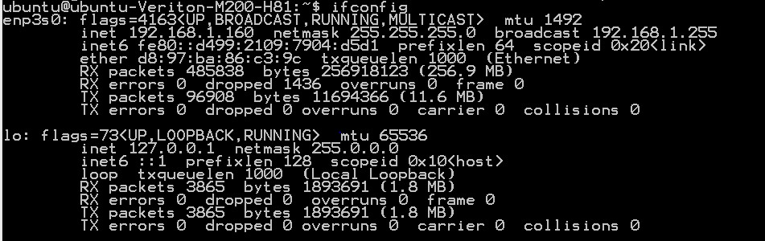

* Options:
* **ifconfig -a:** used to display all the interfaces, even if they are down.
* **ifconfig -s:** used to short list, instead of detailed.

1. **iwconfig:**

* This command is used to view the wireless interfaces on a network.

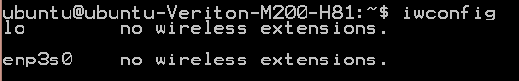

1. **ethtool:**

* This command is used to display the parameters of the Ethernet devices or interfaces.
* Example: ethtool enp3s0

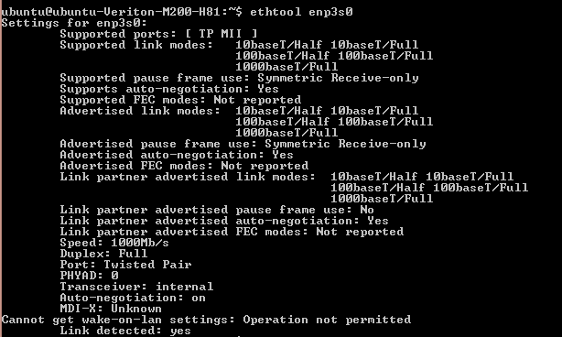

* **Option:**
* **ethtool –S enp3s0:** This option is used to display the byte transfer, received, errors, etc.

1. **arpwatch:**

* This command is used to monitor the Ethernet traffic like changing IP address and MAC address on a network.
* **Example: $** sudo arpwatch –i enp3s0

**$** tail -10 /var/log/syslog

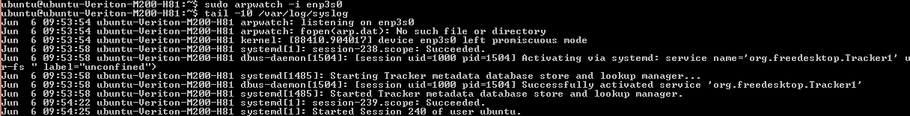

1. **traceroute:**

* This command is used to print the route or hops taken to reach the destination.
* **Example:** traceroute www.google.com

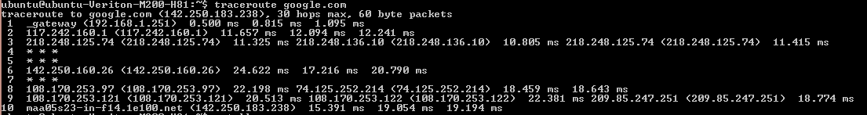

1. **iftop:**

* This command is used to display the table of current bandwidth usage by pairs of hosts.
* **Example:** sudo iftop –i enp3s0

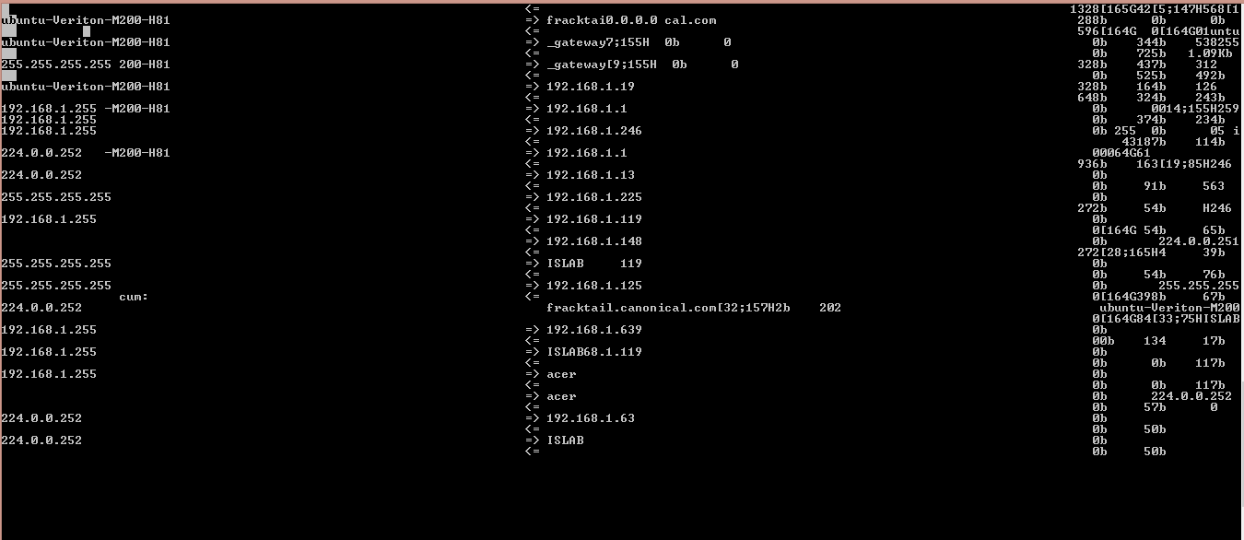

1. **nload:**

* This command is used to monitor the network traffic and bandwidth usage.
* **Example:** nload –m

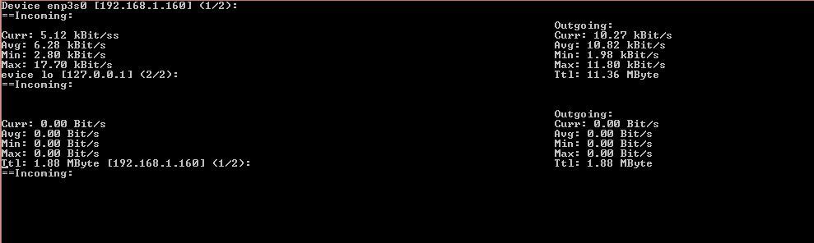

1. **ss:**

* This command is used to dump socket statistics and display information.
* This command is similar to netstat.
* **Example:** ss



* **Option:**
* **ss –t :** This option is used to display the tcp sockets.



* **ss –a:** This option is used to display all the sockets.
* **ss –4:** This option is used to display IPV4 sockets.



* **ss –u:** This option is used to display the UDP sockets.



* **ss –l:** This option is used to show only the listening socket.

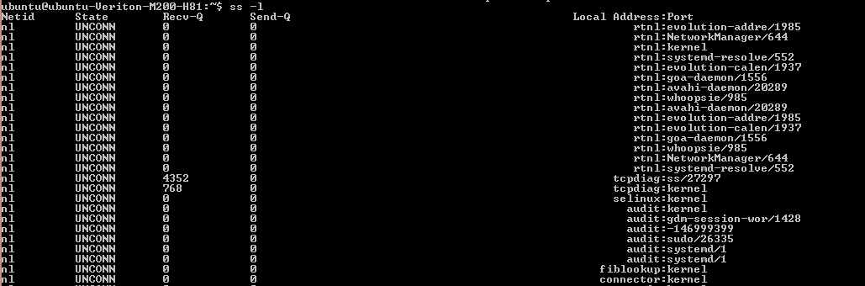

1. **netstat:**

* This command is used to show network statistics like network connection, routing tables, interface statistics, etc.
* It is used to diagnosis network issues and services problems.
* **Example:** netstat

1. **tcpdump:**

* It is a packet sniffing and packet analyzing tool. To troubleshoot network connectivity issues.
* It is also used to capture, filter, and analyze network traffic such as TCP/IP packets going through system.
* **Example1:** sudo tcpdump –i enp3s0

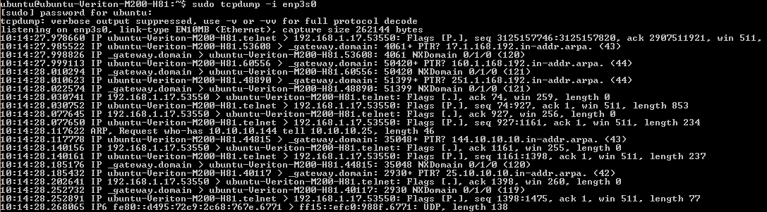

**Example2:** To specify the number of packets to be captured (Here, we have prescribed 5 packets)

sudo tcpdump -c 5 –i enp3s0

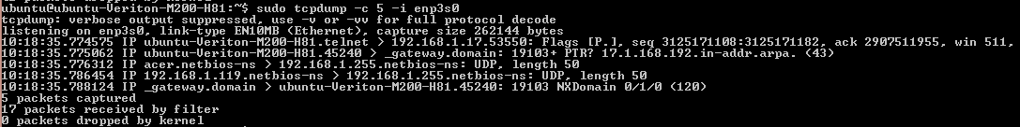

* **Example3:** To print all the packets arriving and departing from the host.

sudo tcpdump host 192.168.1.152



1. **dstat:**

* dstat is a tool that is used to retrive the information or the statistics from the components of the system such as network connection, IO devices, or CPU, etc.
* **Example:** dstat

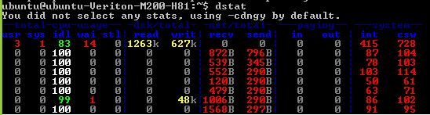

* **Options:**
* **dstat -c:** Enable CPU statistics.
* **dstat -d:** Enable disk statistics.
* **dstat -g:** Enable page statistics.
* **dstat -i:** Enable interrupt statistics.
* **dstat -m:** Enable memory statistics.
* **dstat -n:** Enable network statistics.

1. **bmon:**

* bmon is a network and debugging tool, which captures networking related statistics and displays them in human friendly format.
* **Example:** bmon -p enp3s0

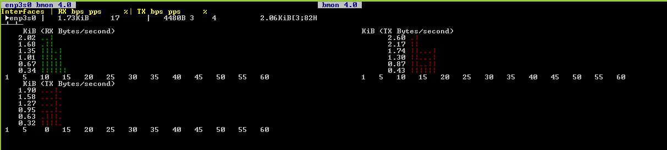

1. **telnet:**

* This command is used to create a remote connection with a system over a TCP/IP network.
* It allows us to administrate other system by the terminal.
* **Example:** telnet 192.168.1.160

1. **ping:**

* This command is used to check the network connectivity between host and a server or a host.
* **Example:** ping 192.168.1.160

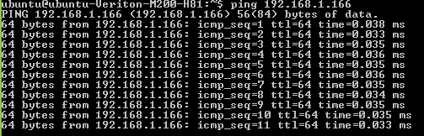

* **Options:**
* **ping -c 5 192.168.1.160:** This command is used to prescribe number of packets to be transferred.
* **ping -s 50 192.168.1.160:** This command is used to prescribe packet size.
* **ping -w 10 192.168.1.160:** This command is used to prescribe the deadline.

**Week 10**

**System Administration commands:**

1. **useradd:**

* useradd command is used to add user accounts to system.
* **Syntax:**

useradd -d /home/newusername -p passwordstring newusername

1. **userdel:**

* userdel command is used to delete a user account and related files.
* It is low-level utility for removing the user.
* **Syntax:** sudo userdel -f -r -Z user

1. **usermod:**

* This command is used to change the properties of the user.

1. **passwd:**

* The passwd command is used to change the passwords for the user accounts.
* A normal user may only change the password for their own account, while the superuser may change the password for any accounts.

1. **groupadd:**

• groupadd command is used to create a new user group.

•**Syntax:** groupadd newgroupname

1. **groupdel:**

• groupdel command is used to delete a existing group.

* It can be handled by superuser or root user.

•**Syntax:** groupdel –f existinggroup

1. **groupmod:**

• groupmod command is used to modify or change the existing group.

• It can be handled by superuser or root user.

•**Syntax:** groupmod [option] groupname

1. **gpasswd:**

* gpasswd command assigns a user to a group with some security criteria.
* **Syntax:** gpasswd [option] group

**Week 11**

**Log monitoring commands:**

1. **df:**

* This command is used to display the information related to file systems about total space and available space.
* **Example:** df /home/ubuntu/ali.txt



* **Options:**
* **df -h:** This option is used for displaying the size in power of 1024.

**Example:** df -h /home/ubuntu/ali.txt

* **df -H:** This option is used for displaying the size in the power of 1000.

**Example:** df -H /home/ubuntu/ali.txt

* **df -T:** This option is used for displaying the type of the file.

**Example:** df -T /home/ubuntu/ali.txt

1. **du:**

* This command is used to view the file memory in a human readable format
* **Example:** du
* **Options:**
* du -s: This option is used to view the size of the directory prescribed.

**Example:** du -h -s /home/ubuntu

* du -k: This option is used to show the memory in kbs.

**Example:** du -h -k /home

1. **top:**

* This command is used to view the details of the running processes and quickly identify issues.
* **Example:** top

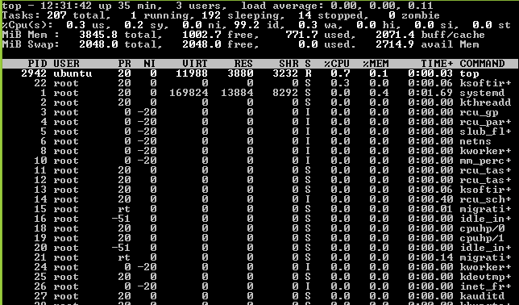

* **Option:**
* **top -p:** To view a particular process.

**Example:** top -p 1

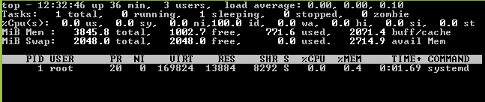

1. **iostat:**

* This command is used for monitoring system IO statistics for devices and partition.
* **Example:** iostat

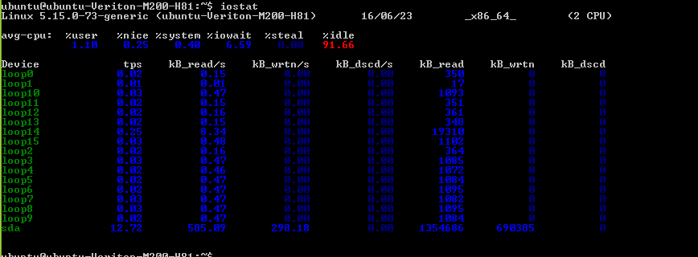

* **Options:**
* **iostat -x:** This option is used for more detailed statistics.
* **iostat -c:** This option is used for only cpu statistics.
* **iostat -d:** This option is used for device report.
* **iostat -k:** This option is used to view the statistics in KBs or MBs.

1. **free:**

* This command is used to view the memory consumption.
* **Example:** free



* **Options:**
* **free -m:** this option is used to view in MBs.
* **free -k:** this option is used to view in KBs.
* **free -g:** this option is used to view in GBs.

1. **cat /proc/cpuinfo:**

* This is used to view what type of processor user is running including the number of CPU’s present.
* **Example:** cat /proc/cpuinfo

1. **cat /proc/meminfo:**

* This is used to determine how much memory the computer has.
* **Example:** cat /proc/meminfo

**maintainance commands:**

1. **shutdown:**

* Shutdown refers to the process of stopping and shutting down a computer or server.
* This involves cutting the power to the main components of the system using a controlled process.
* **Example:** shutdown

1. **rebooting:**

*  Booting is starting a computer's operating system, so rebooting is to start it for a second or third time.
* Rebooting is usually necessary after a computer crashes, meaning it stops working because of a malfunction.
* **Example:** sudo reboot

1. **halt:**

* This command in Linux is **used to instruct the hardware to stop all the CPU functions.**
* Basically, it reboots or stops the system.
* **Example:** halt

1. **init:**

* init is parent of all Linux processes with PID or process ID of 1.
* It is the first process to start when a computer boots up and runs until the system shuts down.
* init stands for initialization.

**System update/ Repositories:**

1. **update the repositories:**

* **sudo apt-get update**
* This command refreshes local list of software, making a note of any newer revisions and updates.
* If there’s a newer version of the kernel, the command will find it and mark it for download and installation.

1. **run the update:**

* **sudo apt-get dist-upgrade**
* The “dist-upgrade” switch asks Ubuntu to handle any **dependencies** intelligently.
* This method is a safe way to upgrade Ubuntu Linux kernel.

1. **packaging manager:**

* Packaging manager is the software used for managing, installing, updating, upgrading etc. of the packages of a system.
* Linux based systems or Linux systems have a lot of such packaging managers in which two are: **yum** and **rpm**.

1. **RPM:**

*  **RPM** stands for **Redhat Packaging Manager**.
* It can be considered one of the oldest packaging managers that do basic functions like uninstalling, updating, archiving the packages received by the Linux systems.

1. **YUM:**

* **Yum** stands for **Yellowdog Updater Modified**. They are packaging managers for RPM based Linux systems.
* They are a high-level front end management package managers for Linux distributions that are RPM-based.

**Week 12:**

**FTP**

FTP allows the user interface to the internet standard file transfer protocol. The program allows a user to transfer files to and from a remote network site.

• Prerequisites:

• Install Ftp (FTP-Client) and vsftpd (FTP-Server) using Software Manager.

• Change /etc/vsftpd.conf file to enable write permission (other settings can be done

according to requirement.

◦ nano /etc/vsftpd.conf

• Search for #write_enable=YES (around 30th line in that file)

• Uncomment and Save and Exit

• Restart the Service: systemctl restart vsftpd

**Example 1: Get the connection to ftp**

• ftp 192.100.100.2 21

• Enter user name and password for connection, this will take user to ftp utility and then

issue ftp command sets

• For more command take the help by issuing ? and to quit utility type quit command.

**Example 2: Download the file from ftp server (Connection done in Example 1)**

• get a.txt /home/admincs/Desktop/test.txt

will download the file a.txt from ftp server to current user Desktop with file

name test.txt

**Example 3: Upload the file from local machine to ftp server (Connection done in Example1)**

• put /home/admincs/index.html test.html

• will upload the file index.html from current (local /home/admincs) user to remote ftp

server with name test.html

Example 4: User can issue commands like mkdir, cd, rmdir etc linux basic commands to

control the remote server machine. (for more commands go to ? Command and man ftp

command)

Install ftp (Ftp-client) and vsted(FTP-Server)using software manager.

Change /etc/vsftpd.conf file to enable write permission .

cano /etc/vsftpd config

Search for FI write - enable = yes

On comment and save and exit

Restart the service: System restart vsftp

Prerequisites

for all commands use sudo bash

Install apaches server apt -get install apache 2

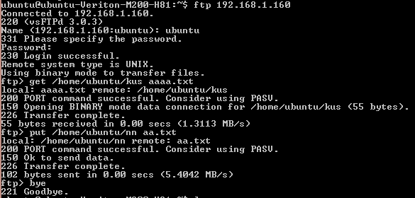

**Week 13:**

**Storage commands:**

1. **fdisk:**

* fdisk is used to check the partitions on a disk.
* The fdisk command can display the partitions and details like file system type.
* **Example:** sudo fdisk -l

1. **sfdisk:**

* sfdisk utility purpose similar to fdisk, but with more features.
* It can display the size of each partition in MB.
* **Example:** sudo sfdisk -l

1. **cfdisk:**

* cfdisk is a linux partition editor with an interactive user interface based on **ncurses**.
* It can be used to list out the existing partitions as well as create or modify them.
* **Example:** sudo cfdisk /var/log/syslog

1. **parted:**

* parted utility is to list out partitions and modify them if needed.
* **Example:** sudo parted -l

1. **df:**

* df is not a partitioning utility, but prints out details about only mounted file systems.
* **Example:** df -h /home/ubuntu

1. **hwinfo:**

* The hwinfo is a general purpose hardware information tool and can be used to print out the disk and partition list.
* **Example:** hwinfo --block --short

1. **inxi :**

* inxi command display information about various hardware components present on the system.
* **Example:** inxi -D -xx

1. **lsblk:**

* Lists out all the storage blocks, which includes disk partitions and optical drives.
* **Example:** lsblk

1. **blkid:**

* Prints the block device (partitions and storage media) attributes like uuid and file system type. Does not report the space on the partitions.
* **Example:** sudo blkid

1. **pydf:**

* pydf is an improved version of df, written in python.
* Prints out all the hard disk partitions in a easy to read manner.
* **Example:** pydf